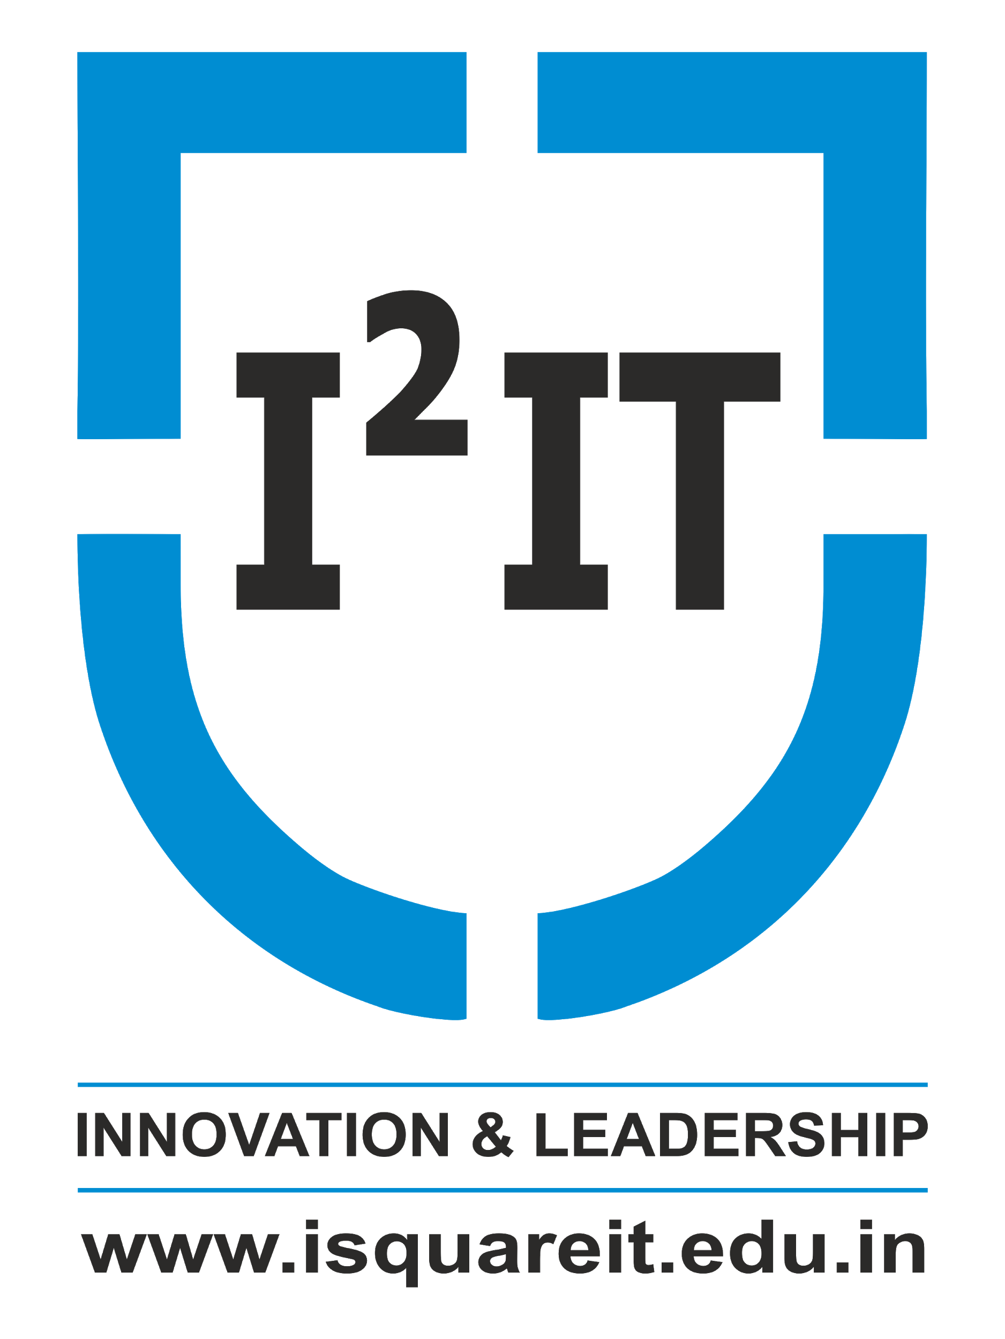 | International Institute of Information Technology
Department of Information Technology
INGENIOUS - 2020
(State Level Project Competition)
on
14th June 2020

Report
“The trick to having good ideas is not to sit around in glorious isolation and try to think big thoughts. The trick is to get more parts on the table.”
- Steve Johnson

An idea is a difference between a successful person and a struggling person. An idea is the light of motivation for those who are trying to make a difference. And also, an idea is the distinction between a creative mind and an ordinary mind.
To honor such ideas and to give a tangling platform for their future growth the Department of Information Technology of International Institute of Information Technology(I²IT) organized a state-level project competition Ingenious. The event was conducted under the flag of The Association for Computing Machinery i.e. ACM Student Chapter of I²IT IT Department. It was conducted on 14th June 2020. The purpose of the event was to showcase various BE projects.
In the times of COVID-19, we conducted this event through online mode, as by now everyone is comfortable with it. The idea was to scrutinize projects of BE students, who have already completed. Participants from different colleges competed in the event to showcase their innovations and claim the prize of the best. We considered two fields for the event- Engineering BE students and Diploma third-year students. The projects were under the domain of Computer Science, Information Technology, Electronics & Telecommunication, Electrical, and Electronics. The subdomains of the projects included Machine Learning, Artificial Intelligence, Deep Learning, IoT, VR, Android, WebApps, Cloud Computing, Apps, Data Science, Data, Blockchain, and many more areas from CS, IT, Electrical and Electronics.
The event was blessed was by three one of a kind Chief Guests. First Chief Guest was Mr. Ajay Deshpande, a VP engineer at Synacor, with 20 years of experience. He is also an eminent ACM speaker. His presence was endearing, and his knowledge about various fields was very vast. The second Chief Guest of the day was Mr. Dinesh Kulkarni, a Data Scientist at Tech Lead Software company. He has work experience of 18 years in this field. His presence was truly the most sublime thing in the event. Our third chief guest was Mr. Dipesh Rane, who works as a Solutions Architect at Synerzip company. He has work experience of 14 years. We were very grateful to have him as our chief guest.
Ingenious got a huge response from the students as different teams from all over Maharashtra participated. All of the projects were amazing, and participants had put a lot of effort into it. They were judged in two rounds in which the key aspects of the project like the working model, presentation, implementation methodology, architecture, and the uniqueness of the project idea were assessed. Every project entry was an example of an excellently worked concept. All the Chief Guests examined the projects and were very impressed by their quality.
There were a total of 53 teams who participated in this event. This was a very overwhelming response that we received. We divided 53 teams in two fields- engineering and diploma, wherein 35 teams belonged to engineering, and 18 to the diploma. Then we classified these teams based on domain. So we had a total of 10 groups, in which every group had 5-6 teams. 7 groups for engineering, 3 for the diploma. Along with our Industry experts, we had an internal jury as well. Internal Juries were from the IT department of our college.
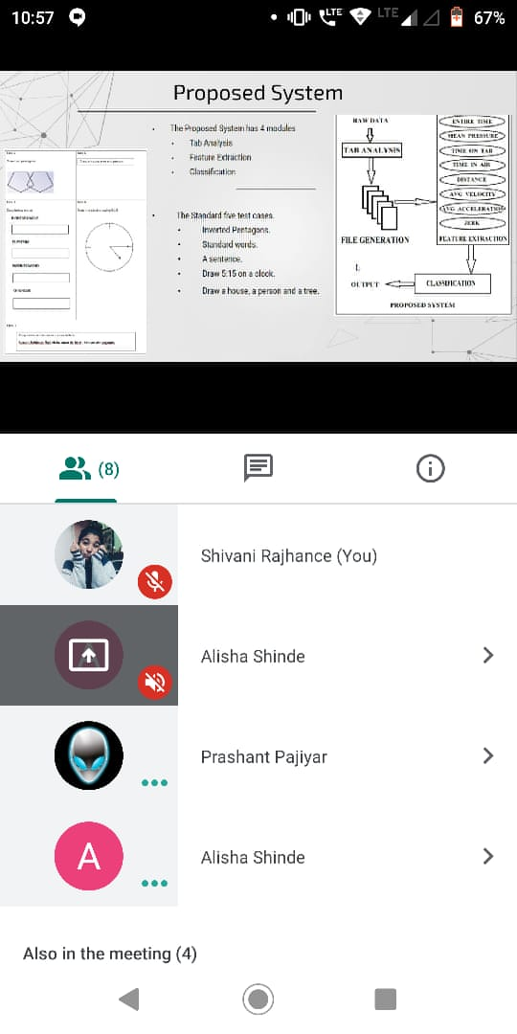
The whole event was conducted on the Google Meet platform. The participants first had to show their presentation, wherein their teamwork, presentation skills were judged. The presentation consisted of five main points- Introduction, Problem Statement, Proposed Methodology along with Architecture, Applications, and Future Scope. The round was based on the presentation and implementation of the model, where 10 minutes given to each. After that, the external jury along with the internal jury questioned the participants regarding their project and model. Both the juries evaluated the project based on the criteria fixed. One winner from each group was chosen.
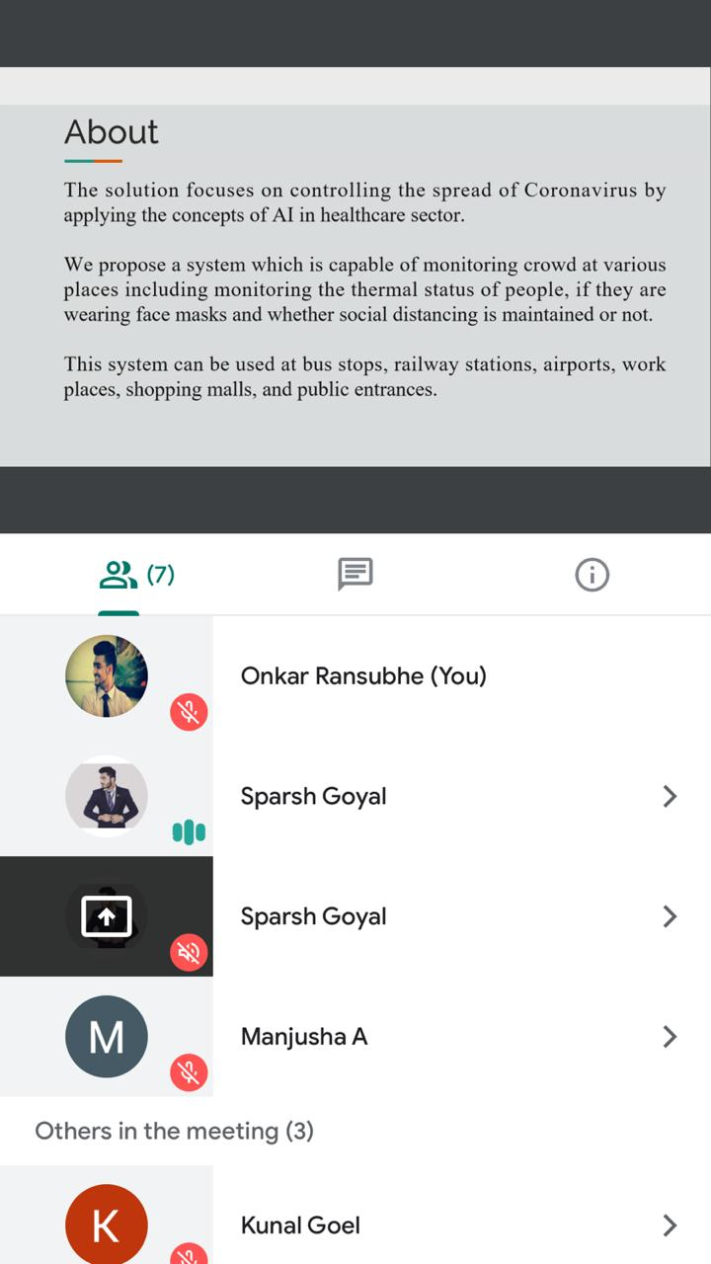
Screenshots of the first round
After the first round, based on the evaluation sheets, we chose a winner from each group. So for the next round, we had 7 teams for engineering, and 3 from the diploma.
Before the commencement of the second round of the project competition, we had Inauguration Ceremony, which was blessed by our three chief guests, Mr. Ajay Deshpande, Mr. Dinesh Kulkarni, and Mr. Dipesh Rane, joined by our Principal ma’am, Dr. Vaishali Patil.
The second round was based on the presentation of the project, implementation of the working model, and question answers by our chief guests. Participants were put to intense Q&A sessions to completely determine the competition winner. For this round, two panels of special guests were organized. The first panel for the engineering group consisted of Mr. Ajay Deshpande and Mr. Dinesh Kulkarni. The second panel for the diploma group had Mr. Dipesh Rane. Both of these panels separately conducted the Q&A sessions with each of the project groups and were extremely delighted with the response and enthusiasm of the students.
With a nail-biting contest among the students, one winner from both engineering and diploma groups were determined. All the panelists had a hard time deciding the clear winner. But in the end, the winner for the Engineering group was Parth Parikh, Akash Rasal, Shantanu Kalamdane, and Khushboo Mundada from Pune Vidyarthi Griha’s College of Engineering. They made a system that will enable students to learn and practice robotics and programming to build solutions and ideas.
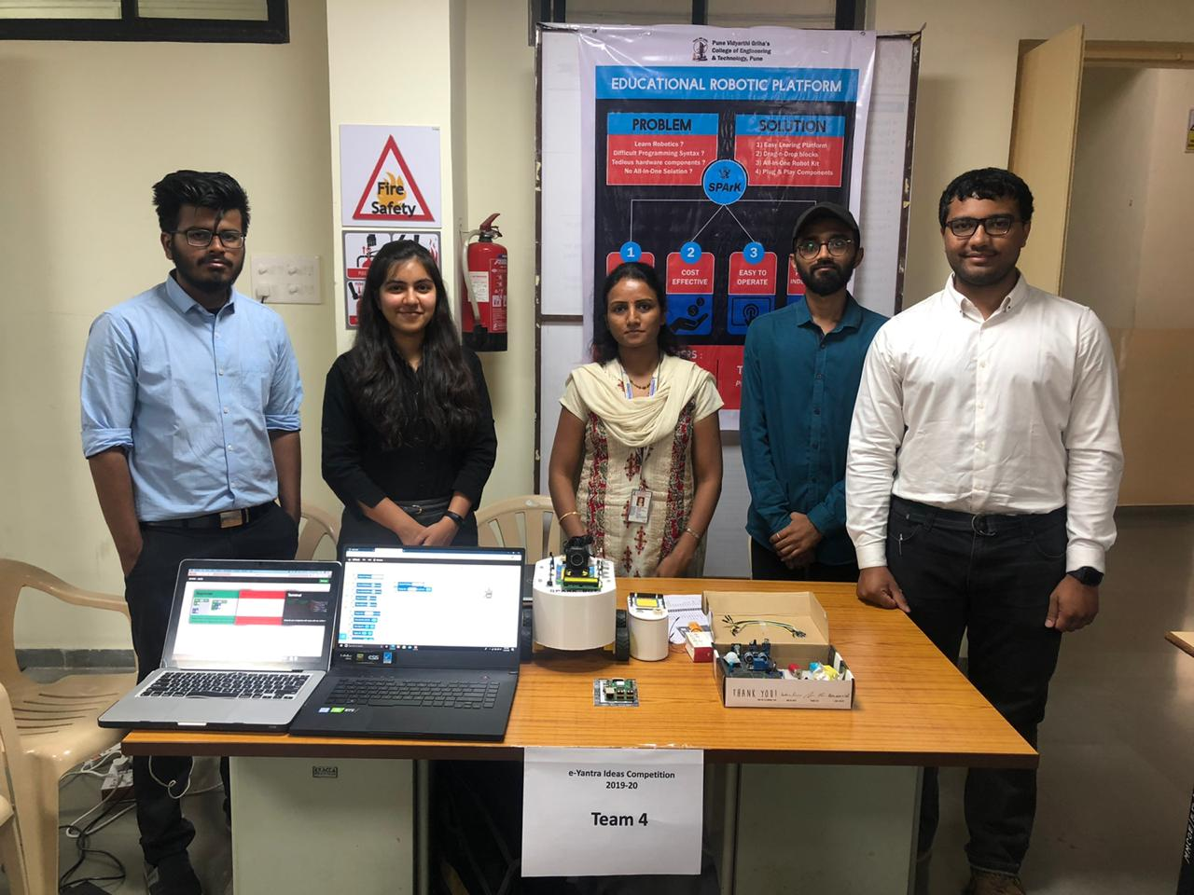
Winner Ingenious 2020- Engineering Team
Winner for the Diploma group was Arpita Kar, Aishvarya Birambole, Aditi Pawar, and Saurav Deore from Government Polytechnic, Mumbai. Their project was Smart LC, which is a vending machine that will be beneficial for both students and teachers.

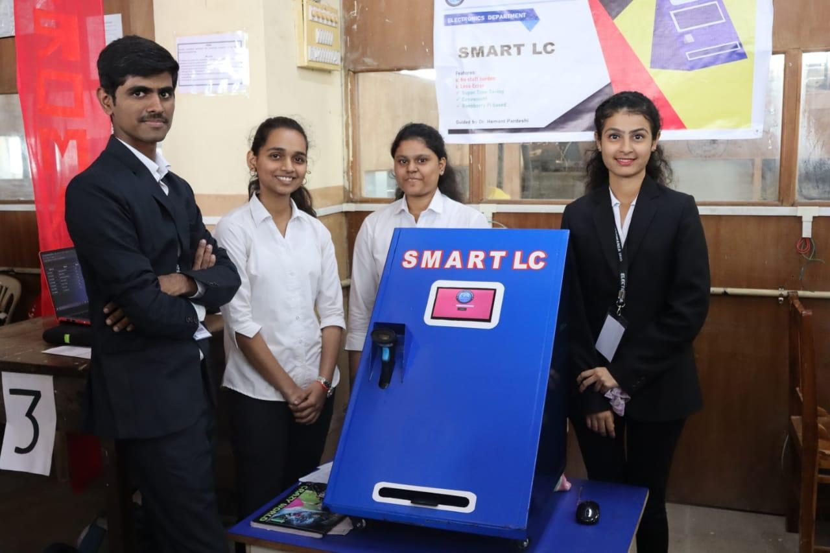
Winner Ingenious 2020- Diploma Team
The event was organized by the ACM student chapter, Department of Information Technology, I²IT, Pune.
Ingenious was a team collaborated effort of all the students and teachers of the ACM Student Chapter of I²IT. All the students worked very hard and endlessly to conduct an event such level. Every student gave their best to make this event a great success. Also, with students all the teachers worked untiringly, helping, and guiding the students at each step. Truly the Ingenious 2020 was an example of great teamwork, unparalleled determination, and beautiful execution!

TEAM ACM and ITSA 2020

