Hope Foundation’s
International Institute of Information Technology (I²IT)
Hinjawadi, Pune- 411057
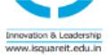
Department of Electronics & Telecommunication

Activity Report

“Guest Lecture on Recent trends in Factory Automation”

Academic Year: 2019-20 Semester: I

Name of Event: Guest Lecture

Date of Conduction: 26th August, 2019

Time: 11:00 am To 12:00 Noon

Targeted Audience: SE,TE & BE E& TC Students

Number of Participants: 169

Venue: A-307,I²IT campus

Topic: “Recent trends in Factory automation need in the Industry”

Resource Person: Mr. Santosh Kulkarni

Coordinator: Prof. Ashvini Kulkarni

Objectives :
- Students will able to explore automation need in the industry.
- To understand Role of electronics engineer in automation industry.
- To understand the need & requirement of automation in an industry.

Outcomes:
- Student will able to understand the design & development process for factory automation.
- Student will able to explore mistubishi electric Cup project competition.
- Students will able to implement automation based projects.
\

Activity Description:
This guest lecture was organized for SE,TE,BE students to make them aware about the ME CUP 2019 challenge and processing with this competition. The guest speaker also guided the students about how to use automotive electronics as a career option .

Event Photos:

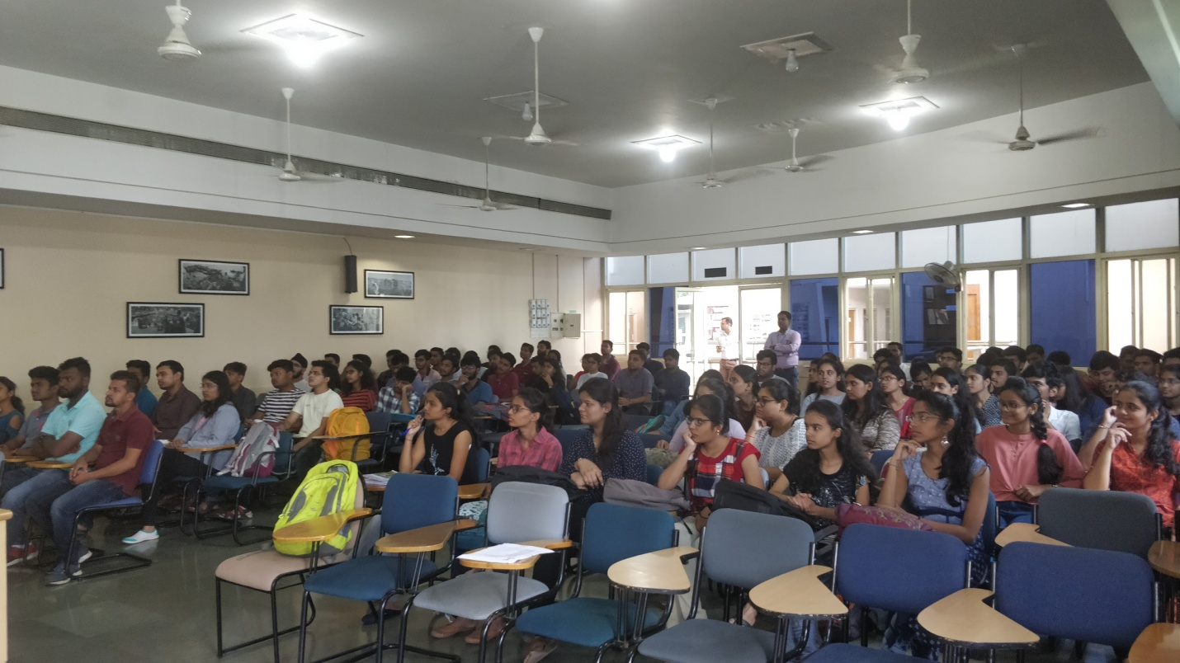

Image 1:Mr. Santosh Kulkarni Addressing to students

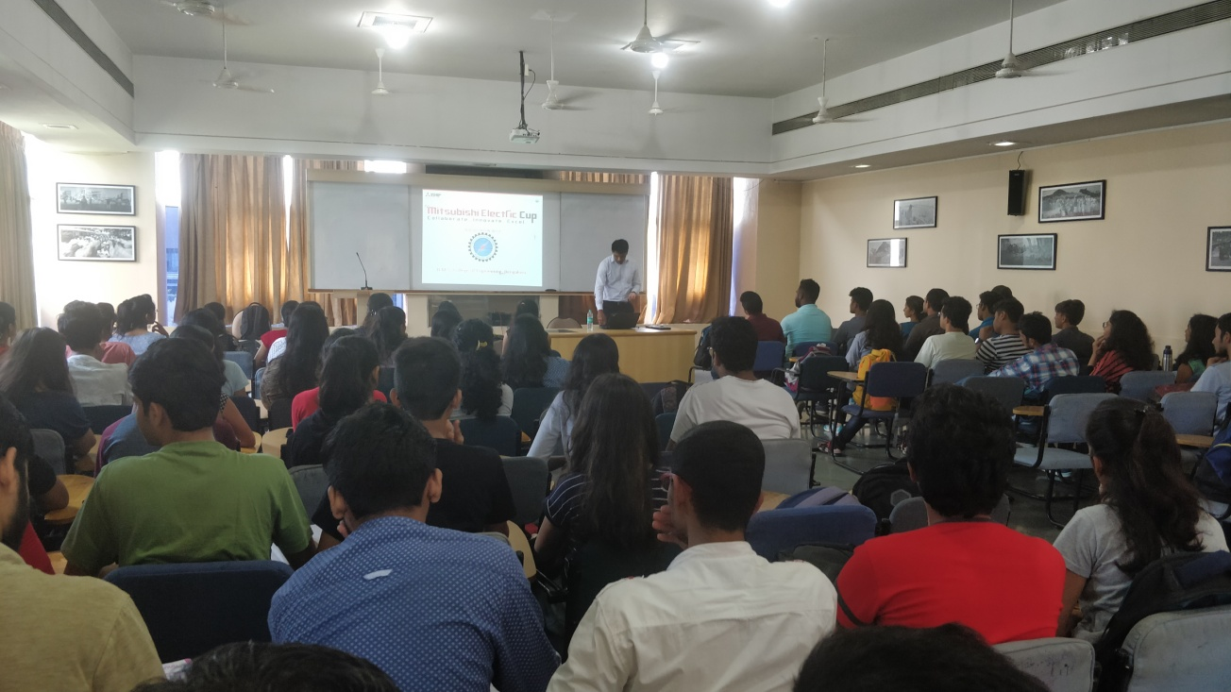
Image 2:Mr. Santosh Kulkarni Addressing to students
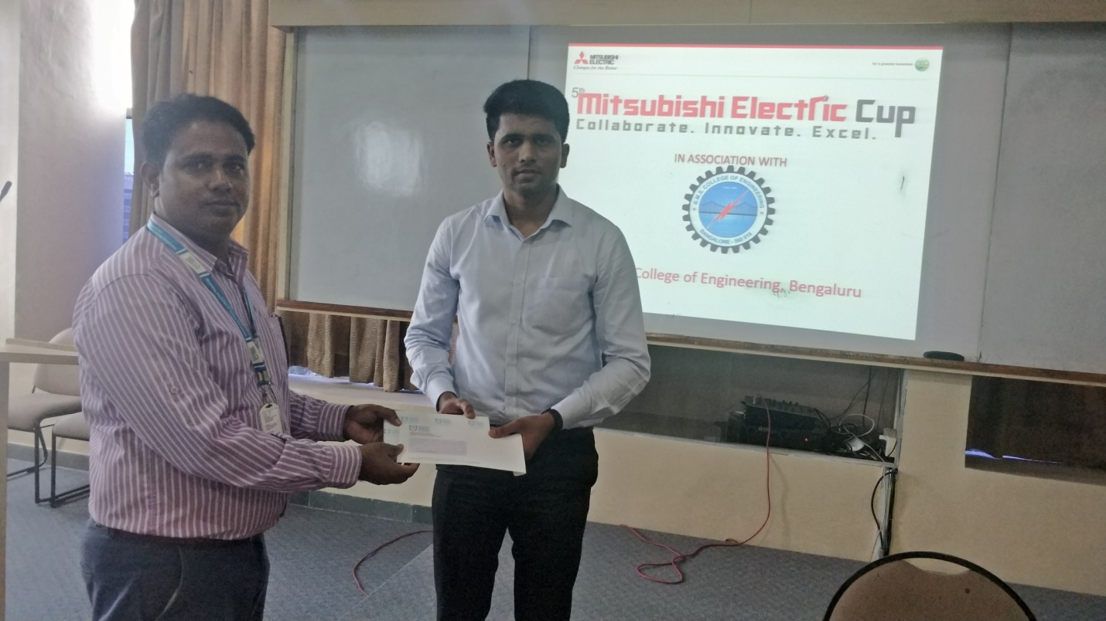 Image 3: Dr. Naidu felicitate to Mr. Santosh Kulkarni

