Hope Foundation’s
International Institute of Information Technology (I²IT)
Hinjawadi, Pune- 411057
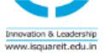
Department of Electronics & Telecommunication

Activity Report

“Expert lecture on Key aspect of
Artificial Intelligence from industry prospective”

Academic Year: 2019-20 Semester: I

Name of Event: Expert Lecture

Date of Conduction: 31 July,2019

Time: 9.30am To 10.30 am

Targeted Audience: BE E& TC Students

Number of Participants: 15

Venue: A-301,I²IT campus

Topic: “Key aspect of Artificial Intelligence from industry prospective”

Resource Person: Ms.Abha Barve , Lead Data Scientist, Pune

Coordinator: Prof. Ashvini Kulkarni

Objectives of the Guest Lecture (minimum 3):
- To understand the concepts of AI through some case studies.
- To understand the numerous applications and huge possibilities in the field of AI that goes beyond the normal human imagination.
- To explore skills required to become as a AI expert in this domain

Outcome of the Guest lecture (minimum 3):
- Design and implement key components of intelligent agents and expert systems.
- Apply and integrate various artificial intelligence techniques in intelligent system development
- To understand the importance of maintaining intelligent systems.

Activity Description:
The expert lecture on Key aspect of Artificial Intelligence from industry prospective for final year students from Electronics & Telecommunication Department.

Event Photos:

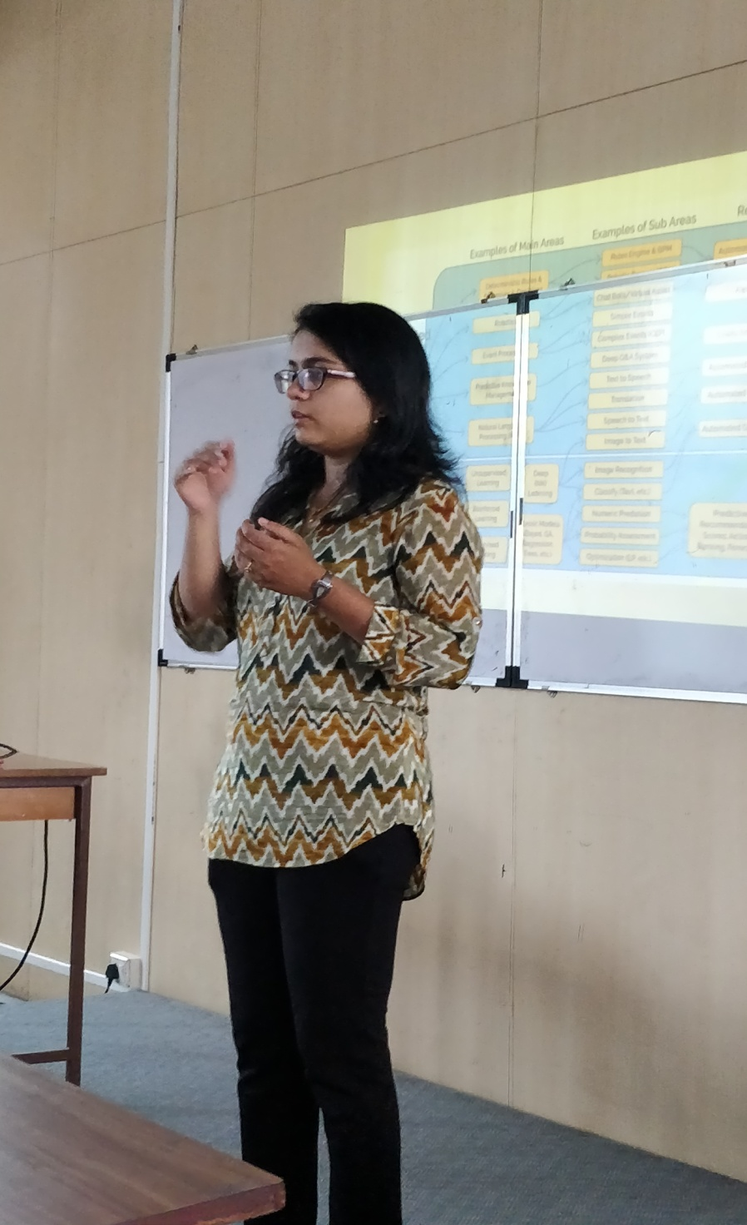

Image 1: Ms. Abha Barve Expressing importance of AI.

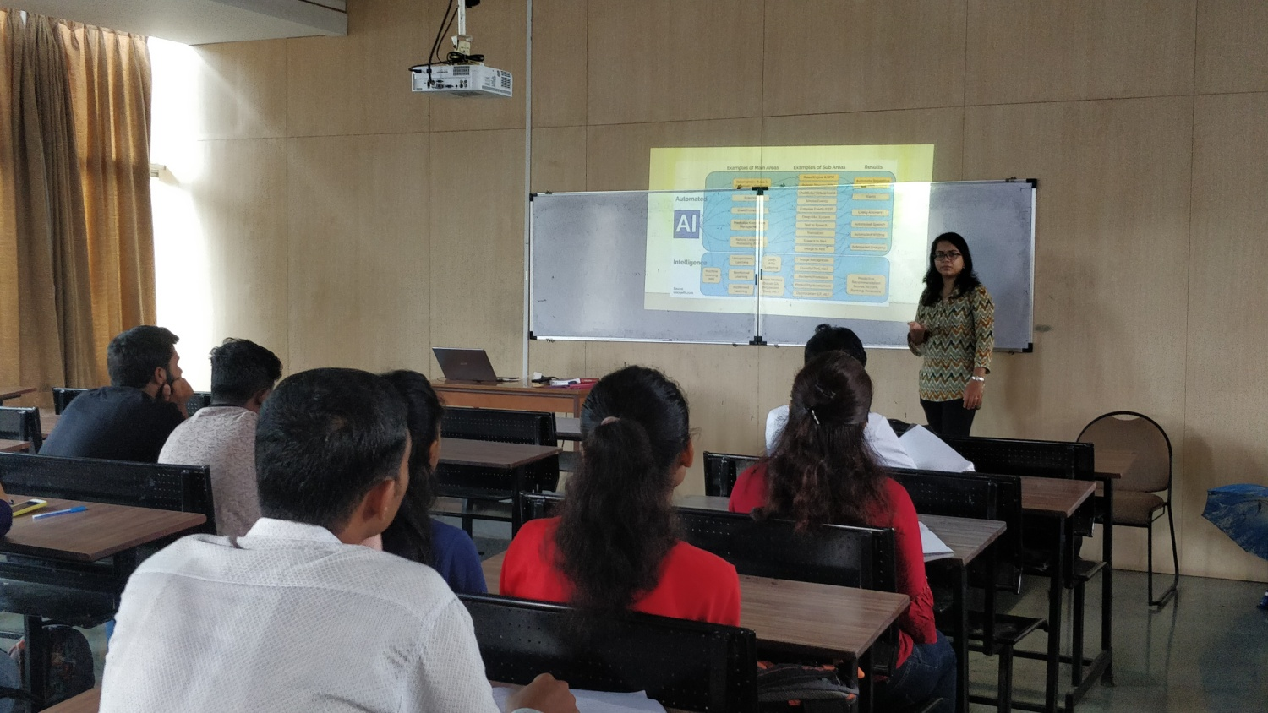

Image 2: Interaction with Students.

