First Year Engineering Student’s Association (FESA) 2019-2020
About FESA: -
FESA stands for First-year Engineering Student Association. FESA is an organization or committee for the students in first year. It is for the FE and by the FE as the committee members also comprise of all the first year’s students. FESA organizes gaming events, quiz, sports and recreational activities for the students. Also, the role of FESA is not just limited to recreation, but any and all problems faced by the students in the first year can be helped to resolve by the FESA committee members.

Objectives: -
- To promote the interaction between academia and industry by organizing industrial visits, special lectures and facilitate in industrial training.
- Promoting the interests of students in various technical areas
- To encourage students to develop their personal skills, like event management & time management by organizing intra & inter Collegiate Events.
- To bring about the technical development of students by organizing seminars, workshops and other activities.

Faculty Advisors: -
Prof. Mandar V. Datar and Prof. Amit B. Kasar

First Year Engineering Student’s Association (FESA) 2019-2020
NOTICE
Date: - 03/08/2019

All students are hereby informed that in order to form the First-year student’s association (FESA), nomination forms are invited for different posts in the FESA committee for Academic year 2019-20. For more details please meet Prof. Mandar Datar and / Prof. Amit Kasar.

Dr. Rakhi Wagh
Head Dept. of Applied Sciences and Engineering

Following Committee members are elected from the nomination forms received for smooth functioning of FESA activities for the academic year 2019-20
Position | Name of the Member/members
President | Kumar Shivam Singh, Ayushi Joshi
Vice President | Yashowardhan Shinde, Arya Pathrikar
Secretary | Swarnim Rai, Ayush Gupta, Pruthvi Inmake
Treasurer | Akhil Bhalerao, Radhika Bhutra
Event Manager | Prathamesh Jadhav, Gunjan Aggarwal, Shekinah Ezekiel, Rohini Rao, Varshita, Namitaa Chandrashekhar, Simran, Ketki, Kalyani, Anamay Dhepe
Tech-Support | Shivam Bhinge, Pratik Bhate, Darshan Patil, Pratik Chitnis, Saurabh Patil, Naman Das
Marketing Head | Isha, Rishab Jain, Omkar Khadke
Photographer | Piyush Nagpal, Vaishali Ghige, Akhil Bhalerao, Aryan k
Committee Members | Aayush Joshi, Surya, Prathamesh Jadhav, Rohini Rao, Shekinah Ezekiel, Varshitaa , Namitaa ChandraShekar , Anamaya Dhepe, Simran , Ketki, Kalyani

Dr. Rakhi Wagh
Head Dept. of Applied Sciences and Engineering

First Year Student’s Association activities A.Y. 2019-20

The following events are planned for first semester
- Intraschool sports event.
- Startup competition.
- Workshop on machine learning

First Year Student’s Association activities A.Y. 2019-20
Minutes of meeting-I
Date: - 09/08/2019
Meeting Chaired by: - Kumarshivam Singh, Yashowardhan Shinde, Arya Pathrikar
Agenda of meeting: - To decide the schedule and activities to conduct in the first FESA event
The following points are discussed: -
Dr. Amit Kasar proposed that there is need to decide the schedule and list of performances for the first FESA event.
- The following schedule is proposed and agreed by all committee members.
Sr. No. | Event Name | Description
1 | Introduction: | Introducing FESA committee
2 | Dares | A small game
3 | Singing | Sadvee Shinde will sing a song.
4 | Riddles | Solving riddles
5 | Dance Performance | It was carried out by Nammita ChandraShekar
6 | Lucky Person | A game
7 | Stand up | Standup comedy by Rucha Paranjpe and Rohan Bhosikar
8 | Prize Distribution | Prizes for winners
9 | Conclusion | -

First Year Student’s Association activities A.Y. 2019-20
Report of Event-I
Event Coordinator: - Prof. Mandar V. Datar, Prof. Amit B. Kasar
Event Conducted on: -10/08/2019
Venue: - Basketball ground, A - 305
Introduction: - This was the first event organized by FESA. Principle Dr.Vaishali Patil and Head of First Year Dr Rakhi Wagh . Inaugurated the event by lightning of lamp. The objectives of FESA are discussed. The brief introduction of FESA committee is given by Prof. Amit Kasar, also he explains the roles and responsibilities of committee members.
About the event: - The event comprises of different indoor and outdoor games which were enthusiastically conducted by fesa members. The first games that were conducted were: -
- Table tennis
- Volleyball
- Basketball
- Carrom
- Football
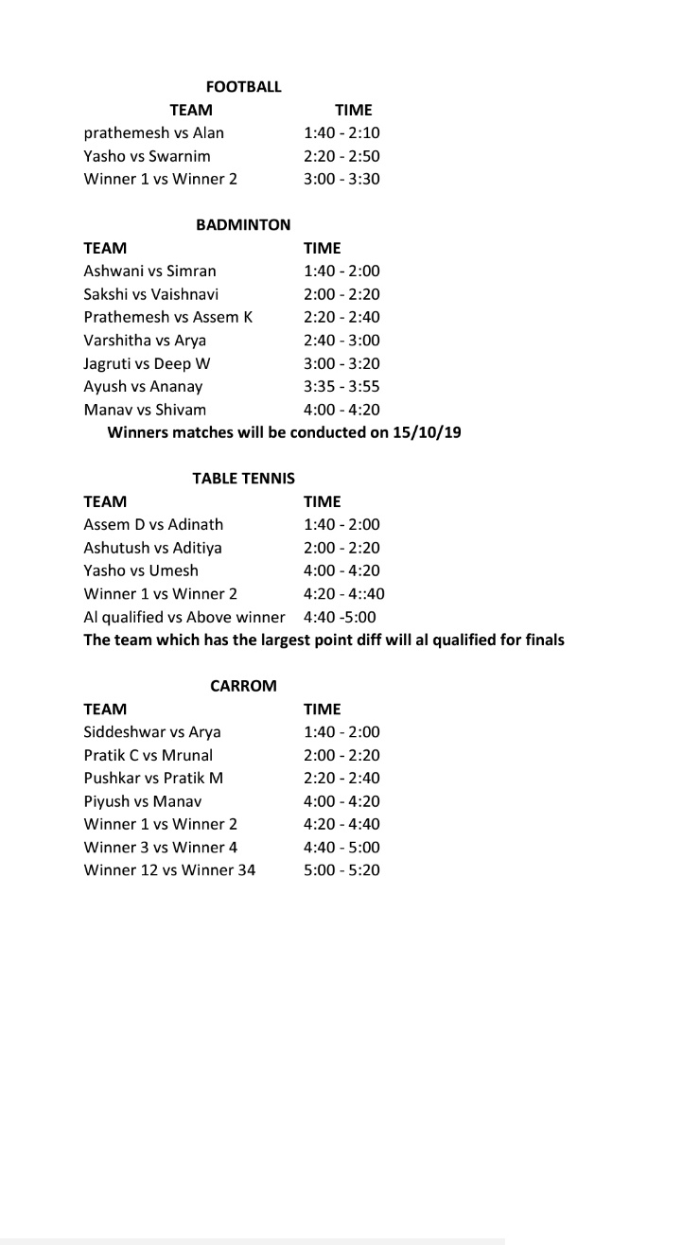
different sports in a sportsman’s spirit. Football

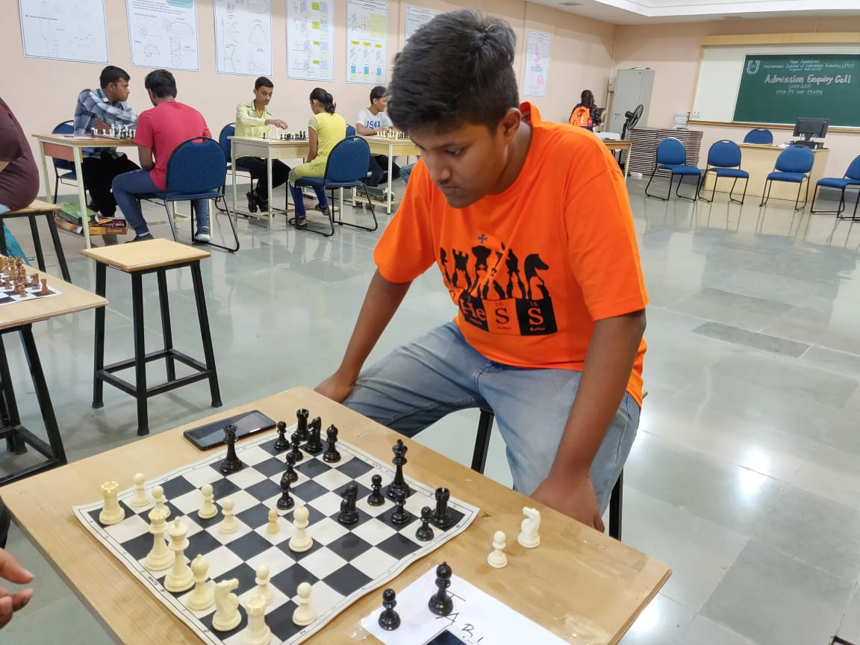
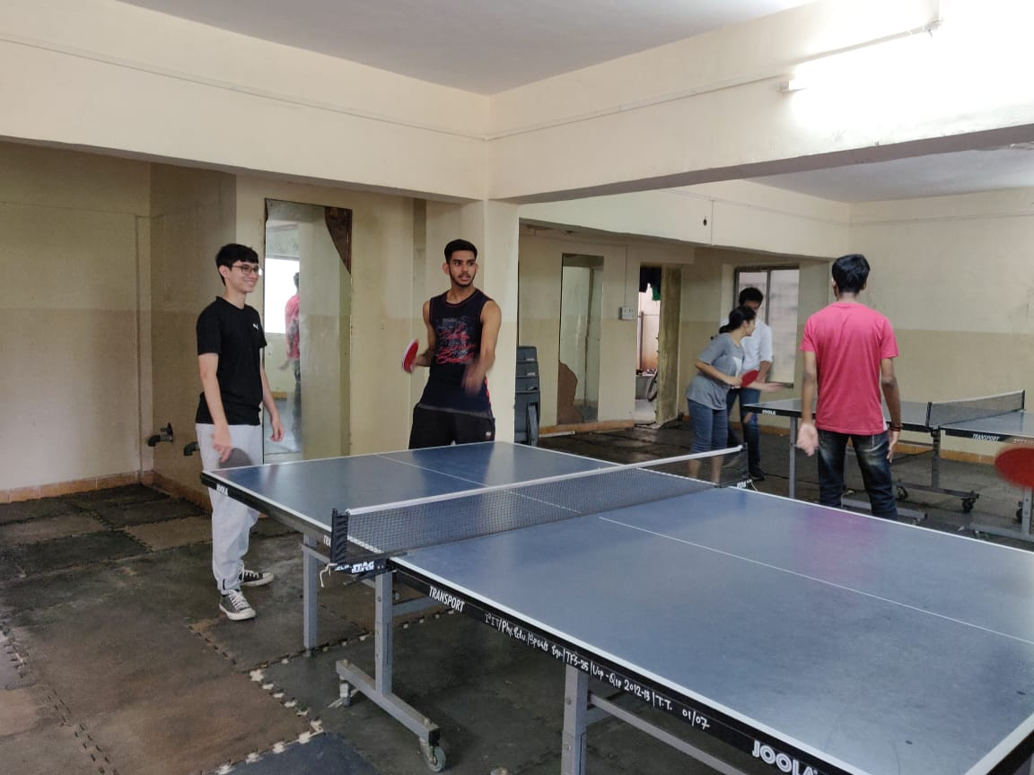
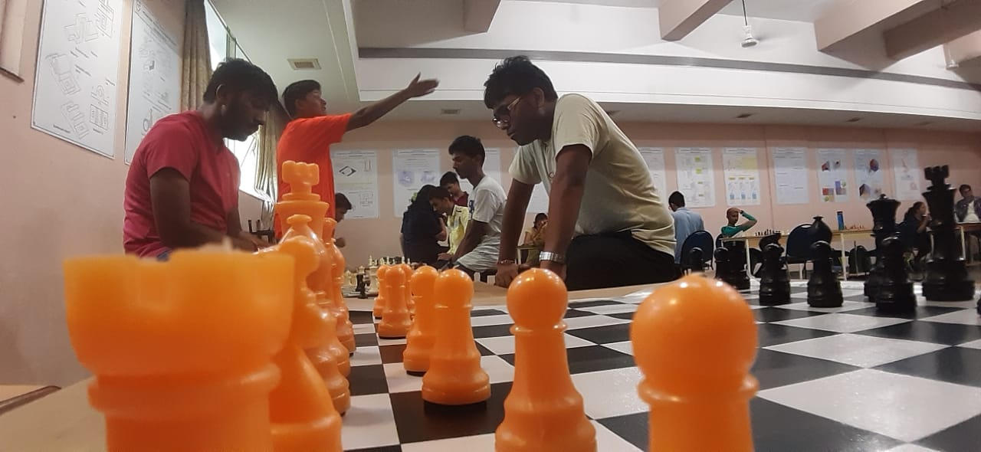

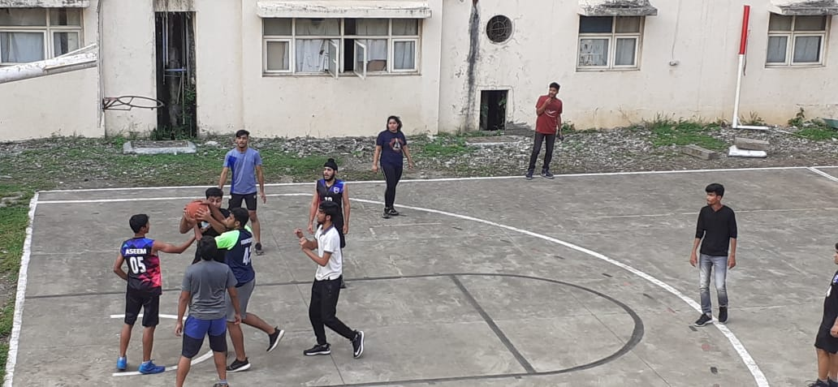

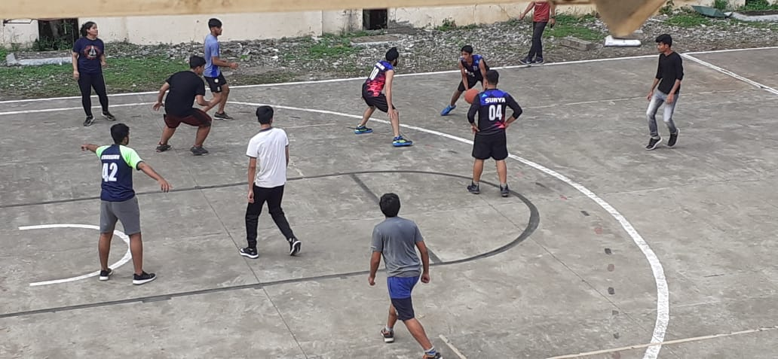
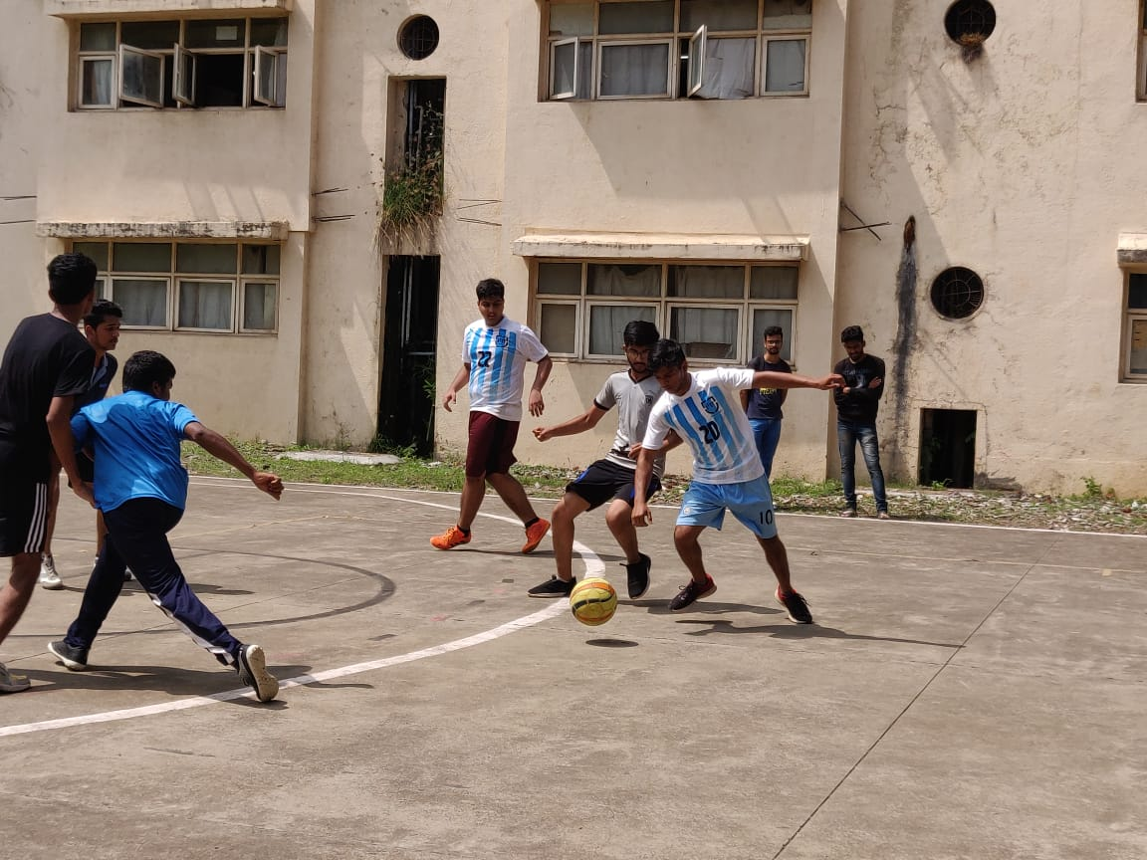
First Year Student’s Association activities A.Y. 2019-20

WINNER OF THE EVENTS:
BASKETBALL: C DIVISION
FOOTBALL: C DIVISION
TABLE TENNIS: YASHOWARDHAN SHINDE AND TEAM
CHESS: VARAD
CARROM: NEHA SURVASE AND TEAM

CONGRATULATIONS TO ALL THE WINNERS

First Year Student’s Association A.Y. 2019-20
Nomination Form
Name: -
Class: -
Designation applied for: -
Contact no. Email
Previous year Percentage: -
Work done by the candidate in past years for the committee

About yourself (hobbies/ any expertise/ achievements)

Please state your vision for the student association

Signature…………………….

