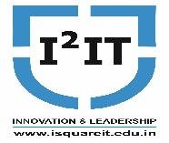
Hope Foundation’s
International Institute of Information Technology,
Hinjawadi, Pune – 411057

Activity Report
(Workshop on Python Programming)

Academic Year: 2019-20 (Sem II)
Name of Event: 3 days Workshop
Topic: Python Programming
Date & Time of Conduction: 2nd Jan 2020 to 4th Jan 2020
Targeted Audience: Second Year Students
Venue: Computer Centre and Department Laboratory
Coordinator: Prof.Bhavana Kanawade
Number of Participants: 34
Activity Description in Nutshell: The session was conducted by Final Year students for Second Year students to make them aware about Python Programming Language.
Topics covered in the session: Decision making statements,looping,list,dictionary,tuple,file and OOP inpython.

Event Photos:

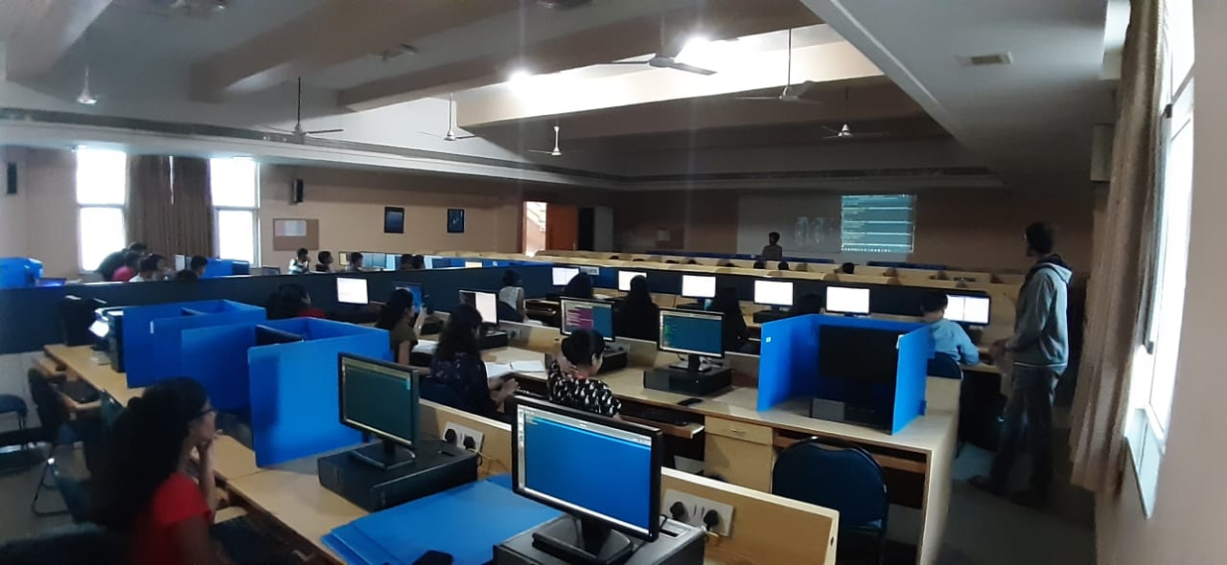
Day 1: Python Programming introduction, Decision making and looping constructs demonstration in computer center

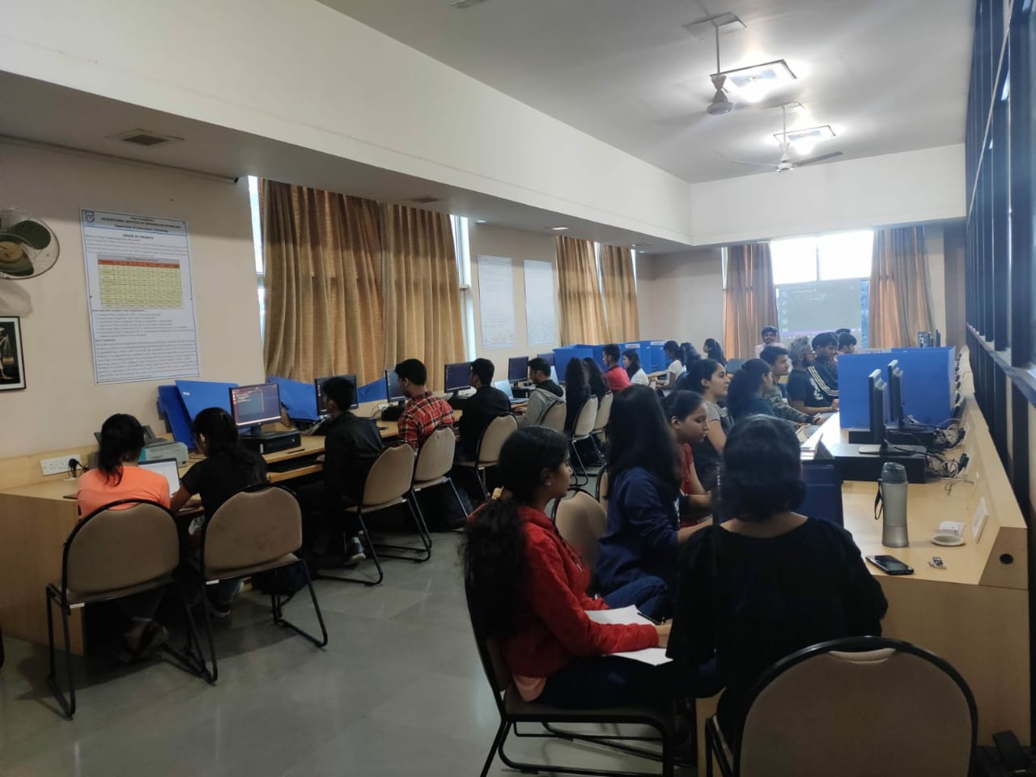
Day 2: List and dictionary concepts with example demonstration in Laboratory

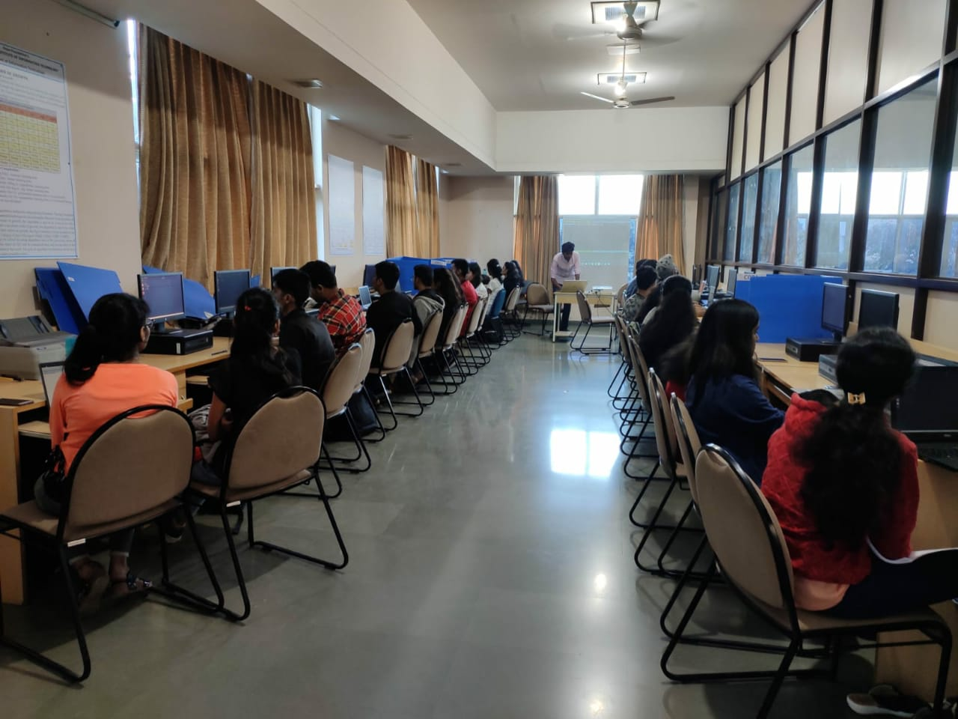
Day 3: Files and object oriented concepts demonstration in department laboratory

