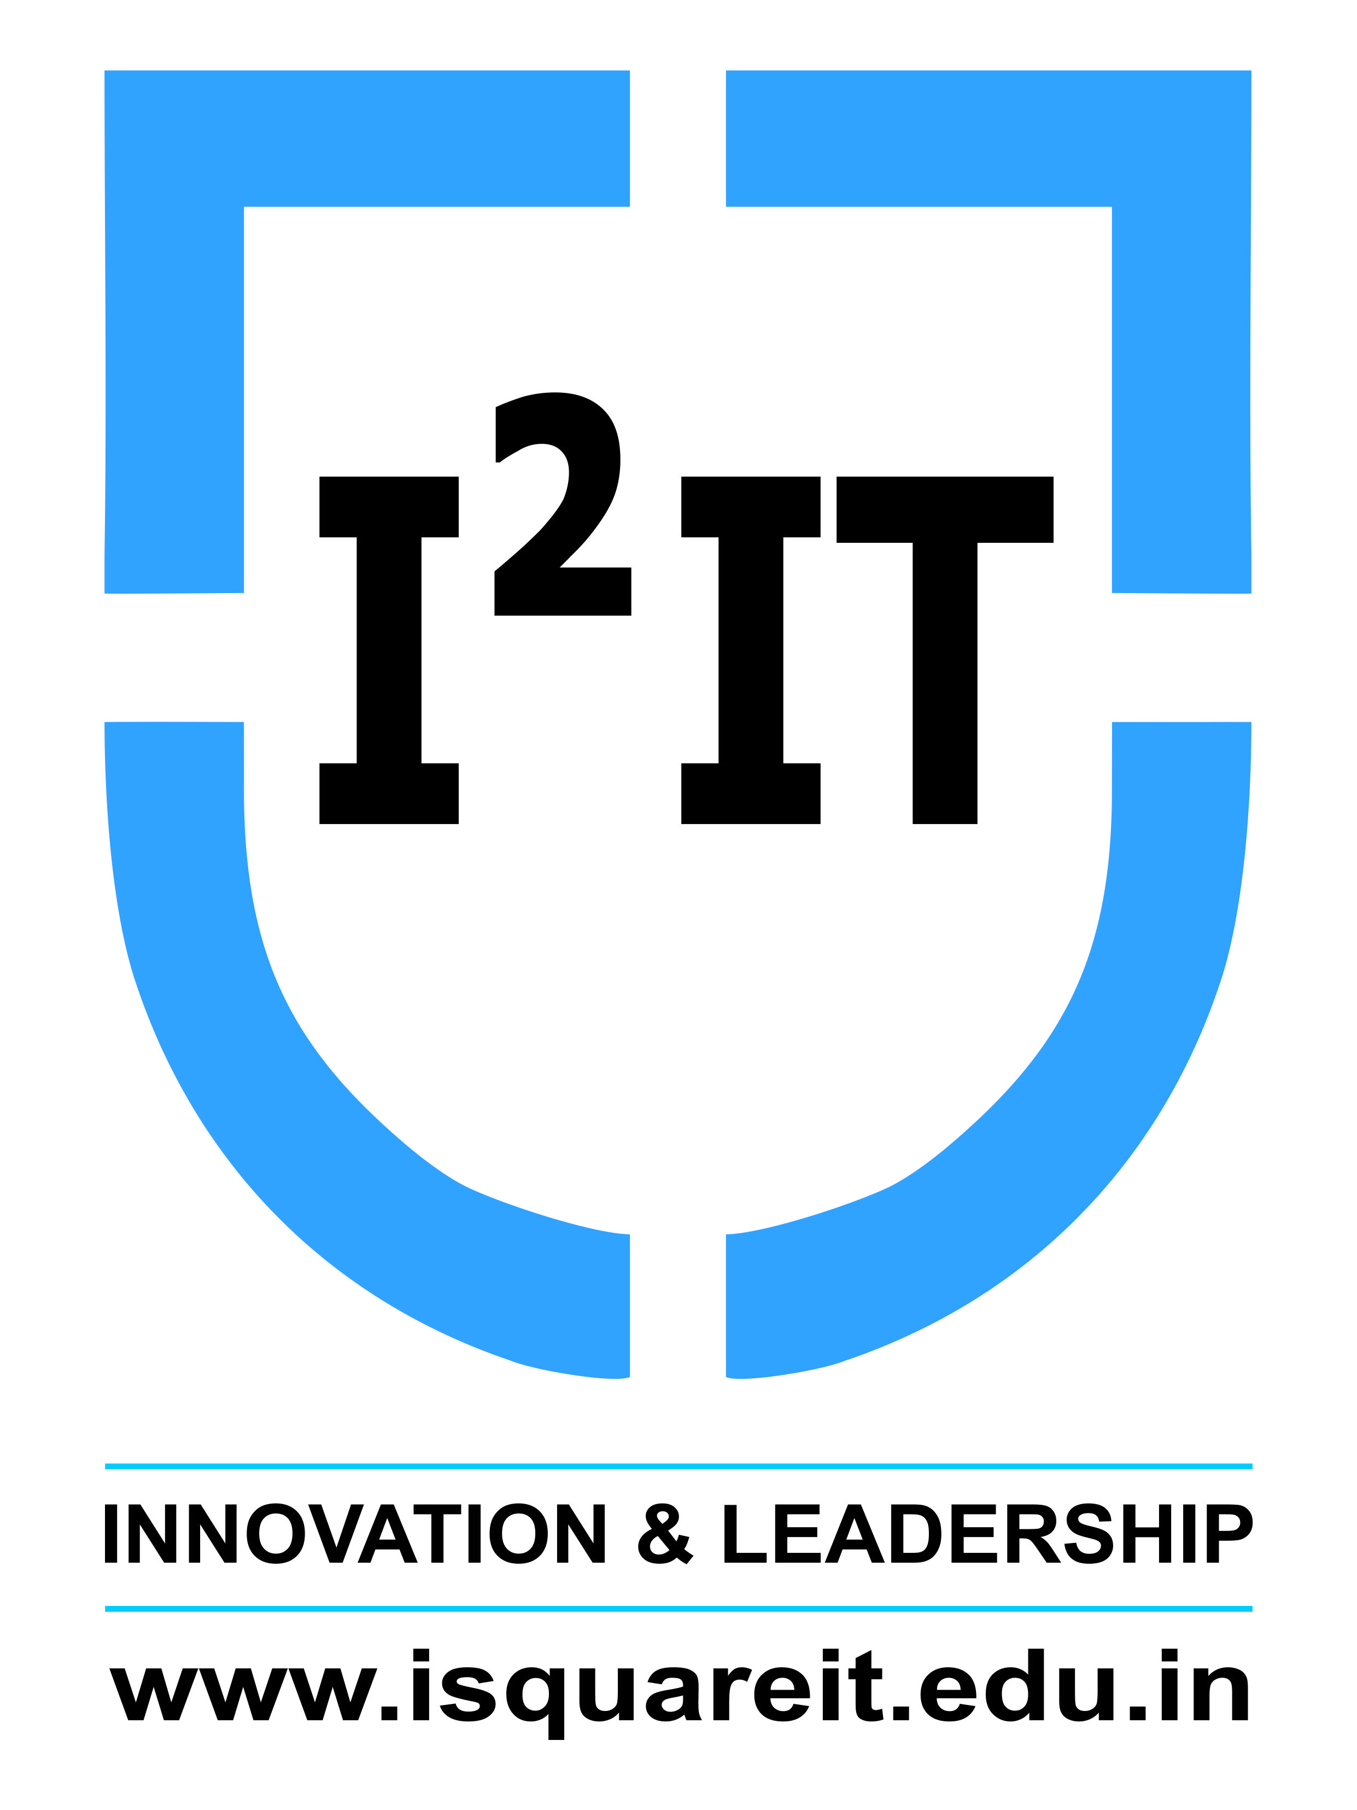
Hope Foundation’s
International Institute of Information Technology,
Hinjawadi, Pune – 411057

Activity Report
MOCK PLACEMENT DRIVE

Academic Year: 2019-2020
Name of Event: Mock Placement Drive
Topic: Placement Drive
Date & Time of Conduction: February 10, 2020 at 2 pm
Targeted Audience: Third Year Students
Venue: Computer Centre and classroom A-222
Coordinator: Rakshitha Shettigar, Akshay Biradar, Nishant Dalvi, Jayan Vinod, Ketan Ingale, Hulasi Khinvasara and Shrushti Jagtap
Number of Participants: 30
Activity Description in Nutshell: This event was conducted by the Final year students for Third year students as a practice for the placement drives they would be going through in the final year. MCQ Aptitude Test, Group Discussion and Interviews were conducted as a part of this event.

Event Photos:
