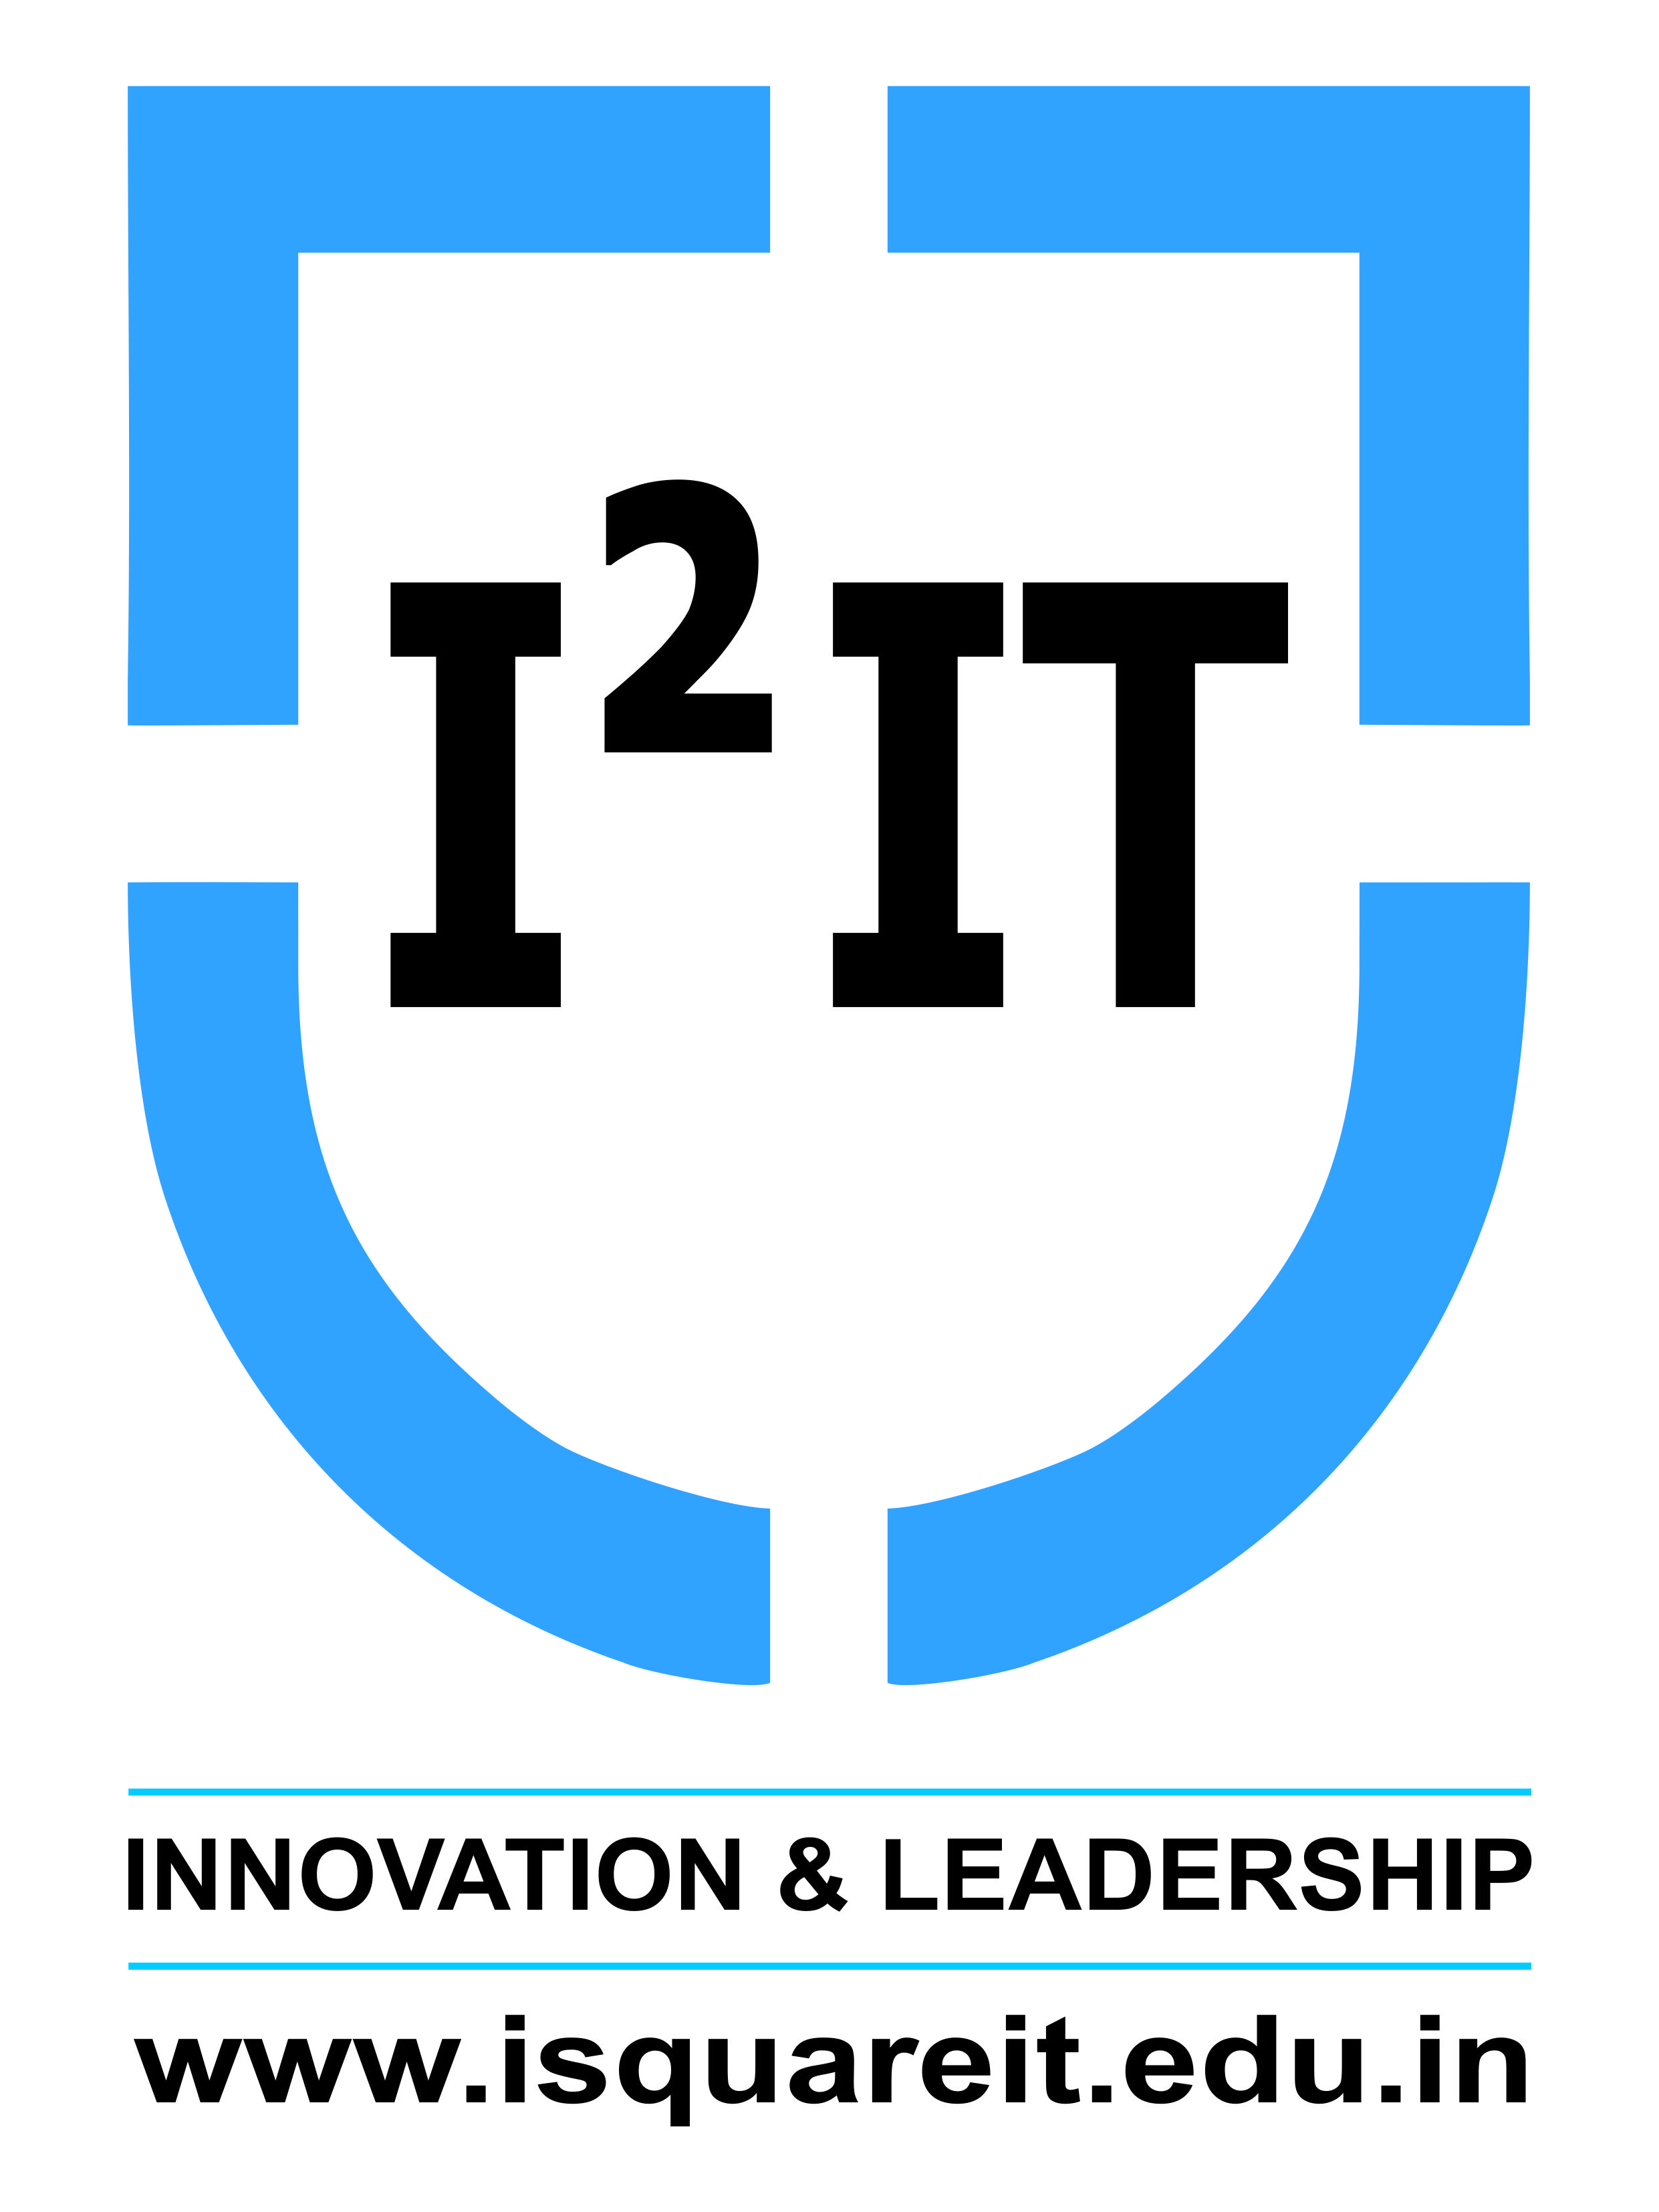
Hope Foundation’s
International Institute of Information Technology,
Hinjawadi, Pune – 411057

Activity Report
Quiz on “C Programming”

Academic Year: 2019-2020
Name of Event: Quiz on “C Programming”
Topic: “C Programming”
Date & Time of Conduction: 16 June to 21 June 2020
Targeted Audience: Diploma Students
Venue: Online Mode/Google Form
Coordinator: Student:- Shrushti Jagtap. Faculty:- Prof. Pradip C & Prof. Prashant G
Number of Participants: 110
Activity Description in Nutshell: This event was conducted by the CESA Team for diploma students. The event consisted of a MCQ “C Programming” knowledge test,

Event Photos:

