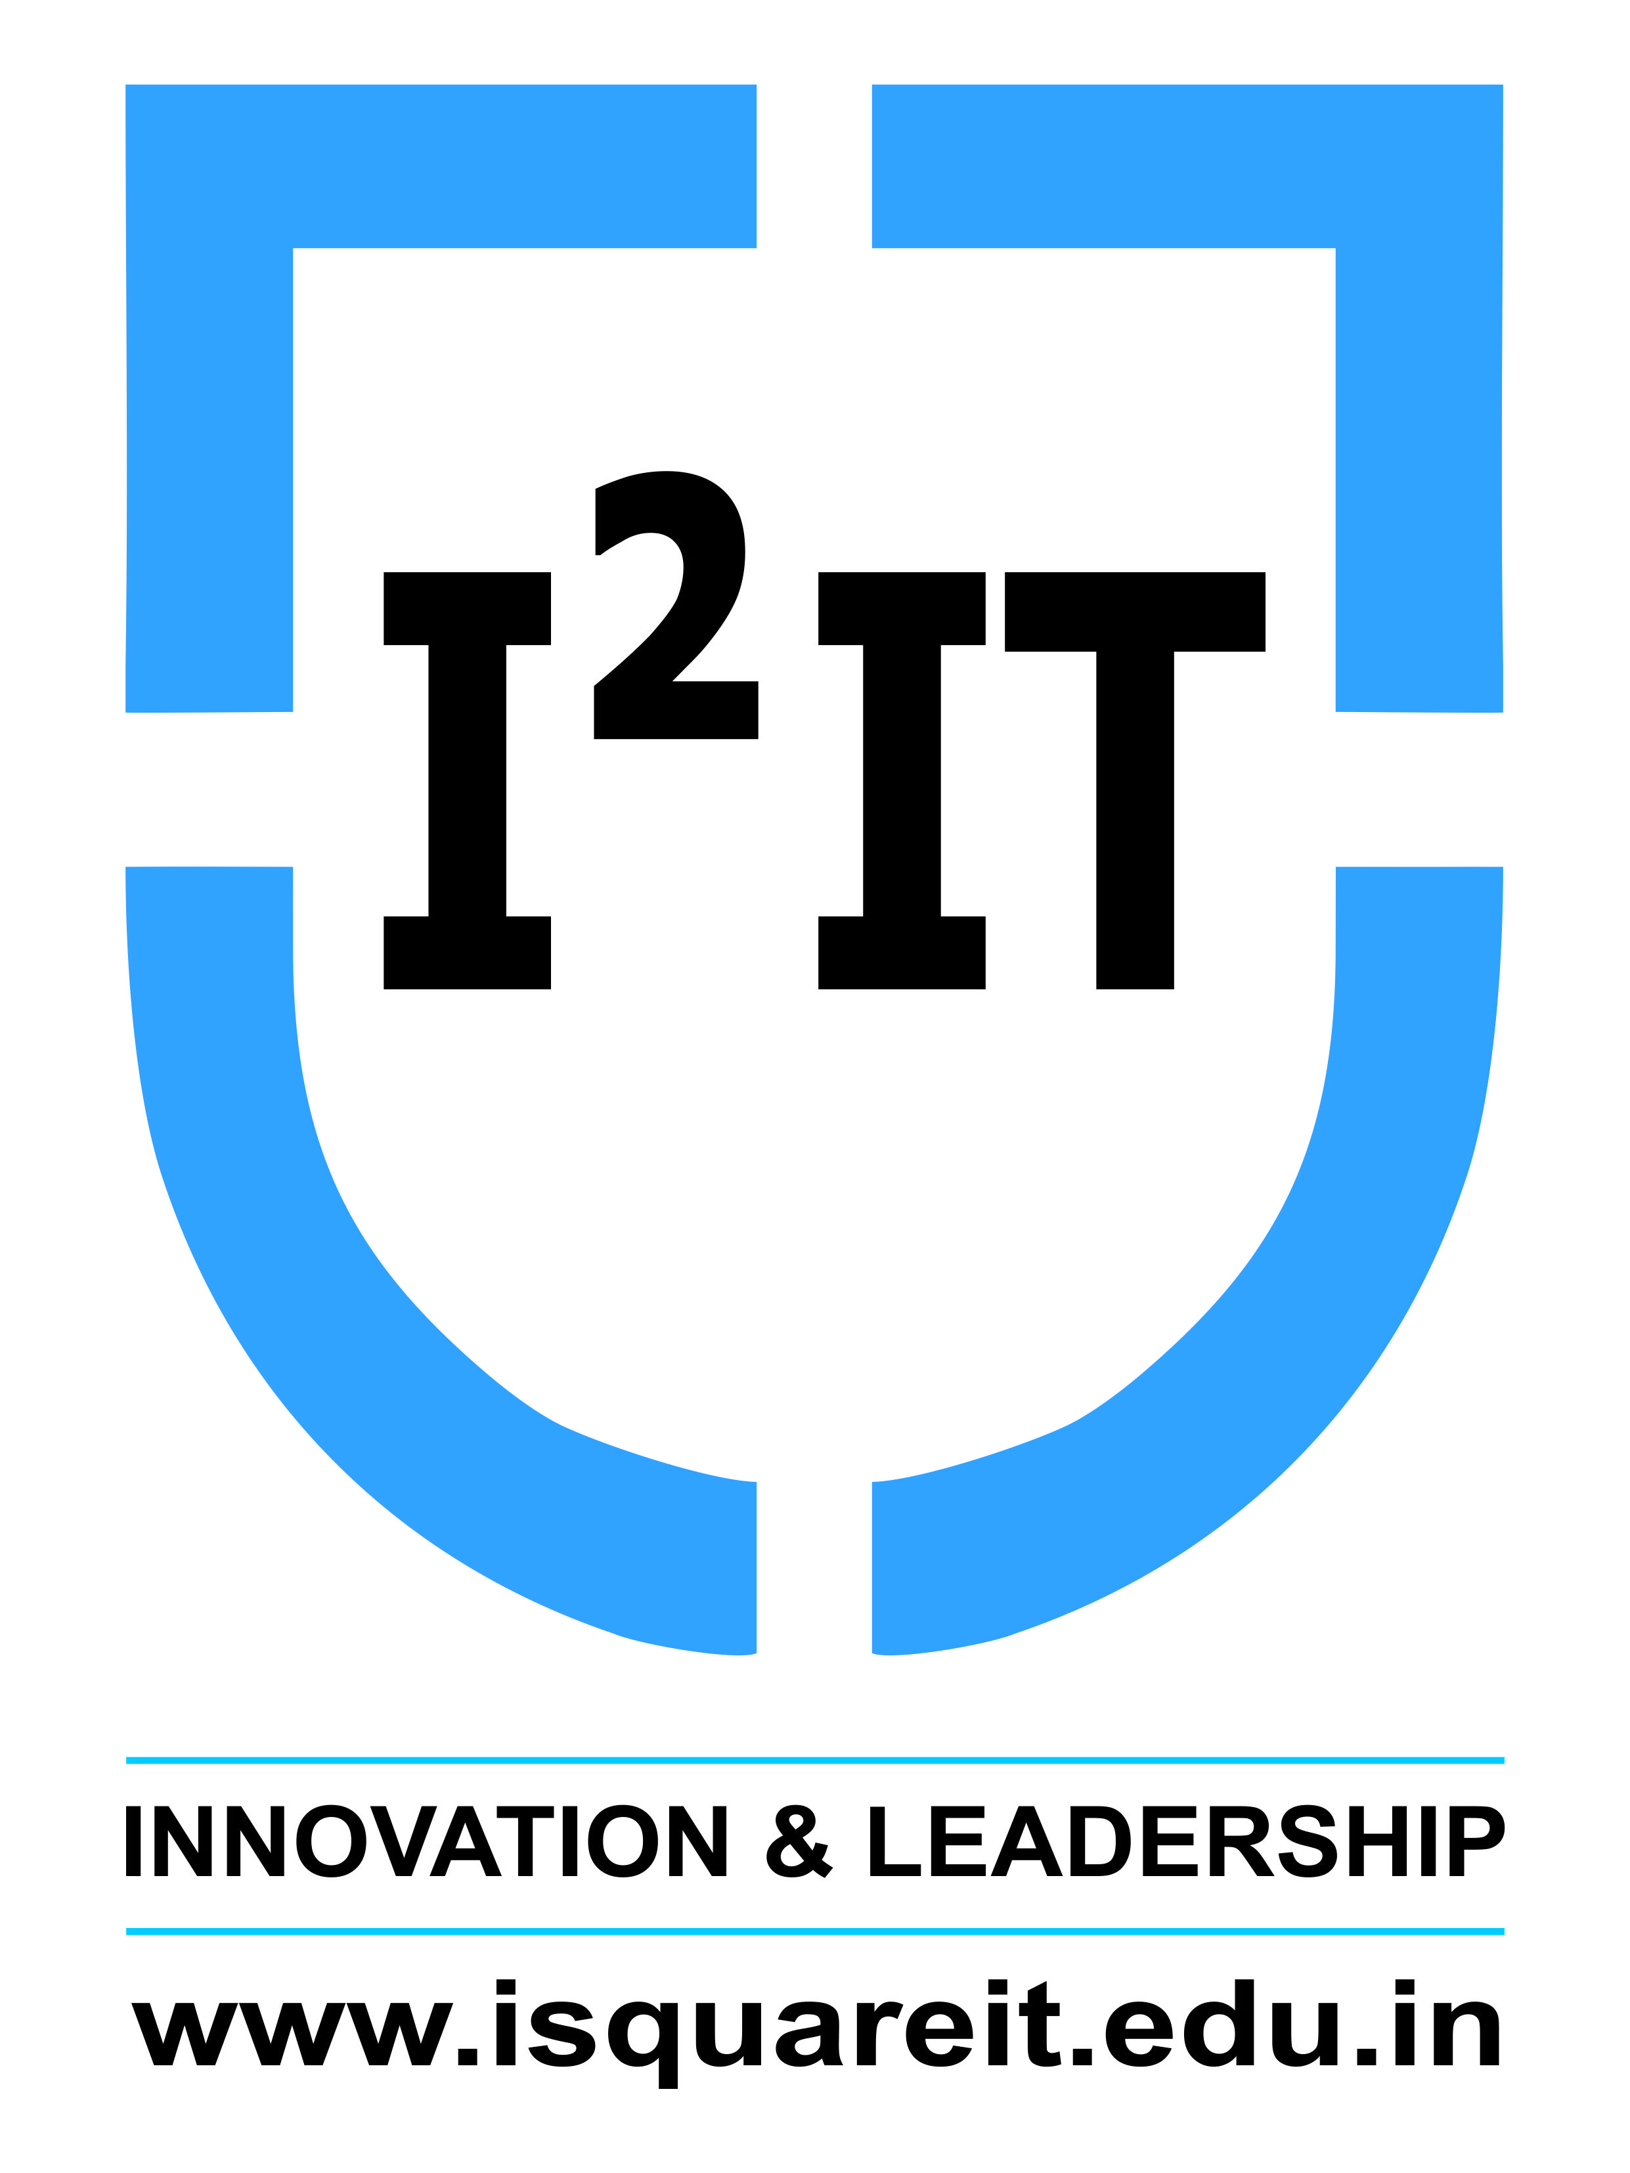
Hope Foundation’s
International Institute of Information Technology,
Hinjawadi, Pune – 411057

Activity Report
QUIZZICAL 2.0

Academic Year: 2019-2020
Name of Event: Quizzical 2.0
Topic: General Knowledge
Date & Time of Conduction: 29, 30 August 2019 at 3 pm
Targeted Audience: First Year and Second Year Students
Venue: Classroom A-222
Coordinator: Shrushti Jagtap, Anubhav Mattoo, Atharv Kulkarni, Anjali Mudaliar, Sharvari Gadiwan, Parth Belwate, Sanika Agarwal, Akshansh Jaiswal, Vidya Bhistannavar, Sejal Kalyankar, Syed Wilayat, Siddhant Dharmatti.
Number of Participants: 34
Activity Description in Nutshell: This event was conducted by the CESA Team for First year and second year students. The event consisted of a MCQ general knowledge test, Crossword Solving and a Buzzer round.

Event Photos:
