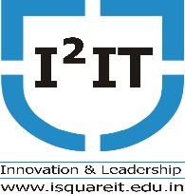
Hope Foundation's
International Institute of Information Technology, Pune

Department of Computer Engineering

29th January, 2020

Name of the Event: Guest Lecture on GATE AWARENESS
Name of Event Coordinator: Prof. Pradip Ashok Chougule
Date of the Event: 29th January, 2020
Resource Person: Mr. Rushikesh Aghase
Number of Participant - 50
Topic – GATE AWARNESS

Objectives: Students able to :
- Understand benefits of GATE examination.
- Understand different service sectors after scoring in GATE examination.
- Understand question patterns in GATE examination.
Outcomes: Student will able :
      - To know the public sectors where students can build career.
      - To know the importance in higher education.

Summary of the Event: GATE exam is to test students knowledge and understanding of their under Graduate level subjects in Engineering. From the awareness lecture Students came to know that there are several public sector undertakings (PSU) (i.e., government-owned companies like Indian Oil, GAIL, and Hindustan Petroleum etc.) recruiting graduate engineers in entry-level positions if they are GATE qualified. To pursue M.E./ M.Tech./ M.Sc programs in any of the leading institutes in the country GATE score must needed.
Photo graphs
