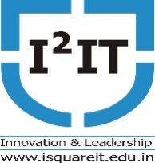

Hope Foundation's
International Institute of Information Technology, Pune
Department of Computer Engineering

Name of the Event: Guest Lecture on Cloud Data Analytics
Name of Event Coordinator: Dr. Sashikala Mishra
Date of the Event: 6th February, 2020
Resource Person: Mr. Ramuka Murari, AtosPune
Number of Participant - 60
Topic – Cloud Data Analytics
Objectives: Students able to learn :
- Different service models in Cloud
- Features of Cloud Computing
- Different services offered in AWS, Azure and GCP
- Data Platform Development Guidelines in Cloud Environment
- Real Industries use cases
Outcomes: Student will able :
      - To know the real industry application
      - To know how to deploy the project on cloud
      - To know various services provided by the cloud
7/02/2020
Summary of the Event: Cloud computing is demand of current era. From the lecture Students learn about the concept of Cloud Computing with the industry aspects. Students are got the industry exposure: for various service models, different services offered in AWS, Azure and GCP data platform development. Students also able to know to deploy the project on cloud
Photo graph
