

**Hope Foundation’s**

**International Institute of Information Technology, Pune**

**Department of Computer Engineering**

**Activity Report**

**Guest Lecture on “Smart Cities”**

**Date: 11th Oct 2019**

**Event:** Guest Lecture

**Date:** 10th Oct 2019

**Time:** 09:30 AM to 10:30 AM.

**Target Audience:** SE Computer Engineering Students

**No of Participants:** 68

**Venue:** A-223

**Topic**: “Smart Cities”

**Resource Person:** Prof. Vishal Kadam

**Coordinator:** Prof. Ramkrushna M.

**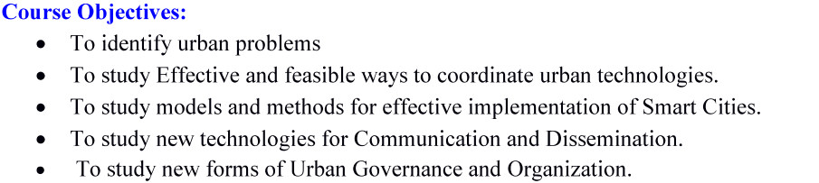**

**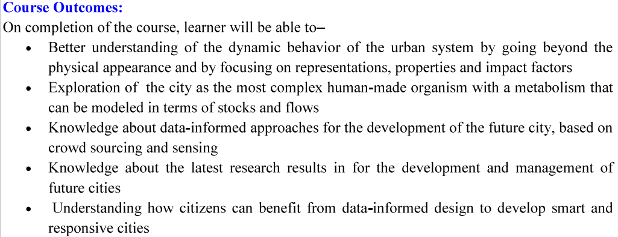**

**Activity Description:**This guest lecture was organized for SE students to make them aware about Smart cities projects running in India. The guest speaker guided various day to day life example how we can maintain smart cities. He even has shown various case studies of smart cities. The speaker had given shown some videos too; get the clear idea of exactly what are developments going in smart city projects.

**Photographs of event:**

|  |  |
| --- | --- |
| IMG_20191010_093930 | IMG_20191010_093948 |
| IMG_20191010_093854 | IMG_20191010_093833 |