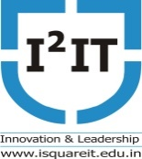

Hope Foundation's
International Institute of Information Technology, Pune - 411057
Department of Computer Engineering
10/02/2020

Event: Guest Lecture

Date: 7th February, 2020

Time: 8:30am to 10:30am

Target Audience: 50

No of Participants: 40

Venue: A223

Topic: Natural Language Processing
Resource Person: Mr. Animesh Samuel, NLP Bolt Pune

Coordinator: Prof. Prashant Gadakh
Objectives: Students able to learn
Different methods related to NLP
Features of NLP
How to develop Chat Bots
Real use cases

Outcomes: Student will able
CO1: To know the real industry application
CO2: To know how to develop the chat bots
CO3: To know various applications on NLP

Summary of the event
Natural Language processing is demand of current era. From the guest lecture Students learn about the concept of NLP, NLP applications with the industry aspects. Students are got the industry exposure: for various services.

Photo graphs
