

**Hope Foundation’s**

**International Institute of Information Technology, Pune**

**Department of Computer Engineering**

**Activity Report**

**Guest Lecture on “Complexity Theory”**

**Date: 12/10/2019**

**Event:** **Guest Lecture**

**Date: 12/10/2019**

**Time**: **8.30am to 10.30am**

**Target Audience: 50**

**No of Participants: 47**

**Venue: Seminar Hall (CC)**

**Topic: Complexity Theory**

**Resource Person:** Mr. Vivek Kulkarni (Persistent Pune)

**Coordinator:** Prof. Prashant Gadakh

**Objectives:**

* To learn the advanced concepts of Complexity Theory.
* Make the student to learn the NP Theory and solve the problems.

**Outcomes:**

* Students learn the Complexity theory with real time example also they learn the basic concepts of problem decidability which help them to understand the real life problem solution.

**On completion of this course students are able to**

* Identify the differences between decidability problem and non-solvable problem also they understood the P, NP, NP Complete and NP Hard Theory.

**Event Photographs**

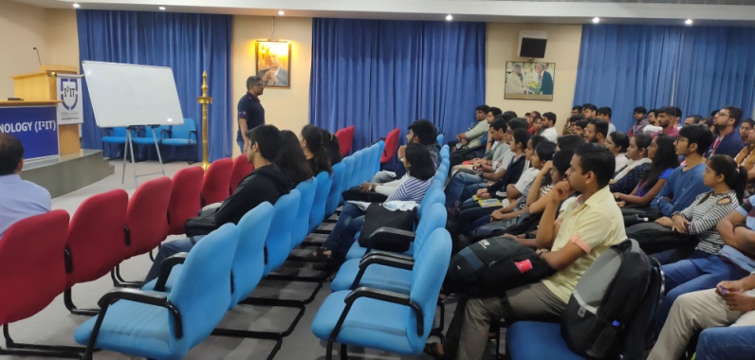

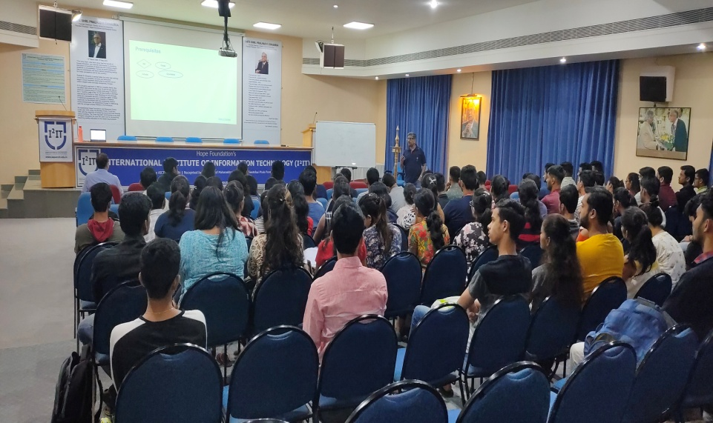



Prof. Prashant Gadakh

Coordinator