Hope Foundation’s
INTERNATIONAL INSTITUTE
OF INFORMATION TECHNOLOGY

DEPARTMENT OF ELECTRONICS & TELECOMMUNICATION
ACADEMIC YEAR: 2019-20 / SEMESTER – I

GMRT Industrial visit on 28 June, 2019
Second year Electronics and Telecommunication students have visited GMRT ,Khodad on 28 June, 2019. This visit has exposed all students with various antenna configuration and its implementation for signal transmission and reception.

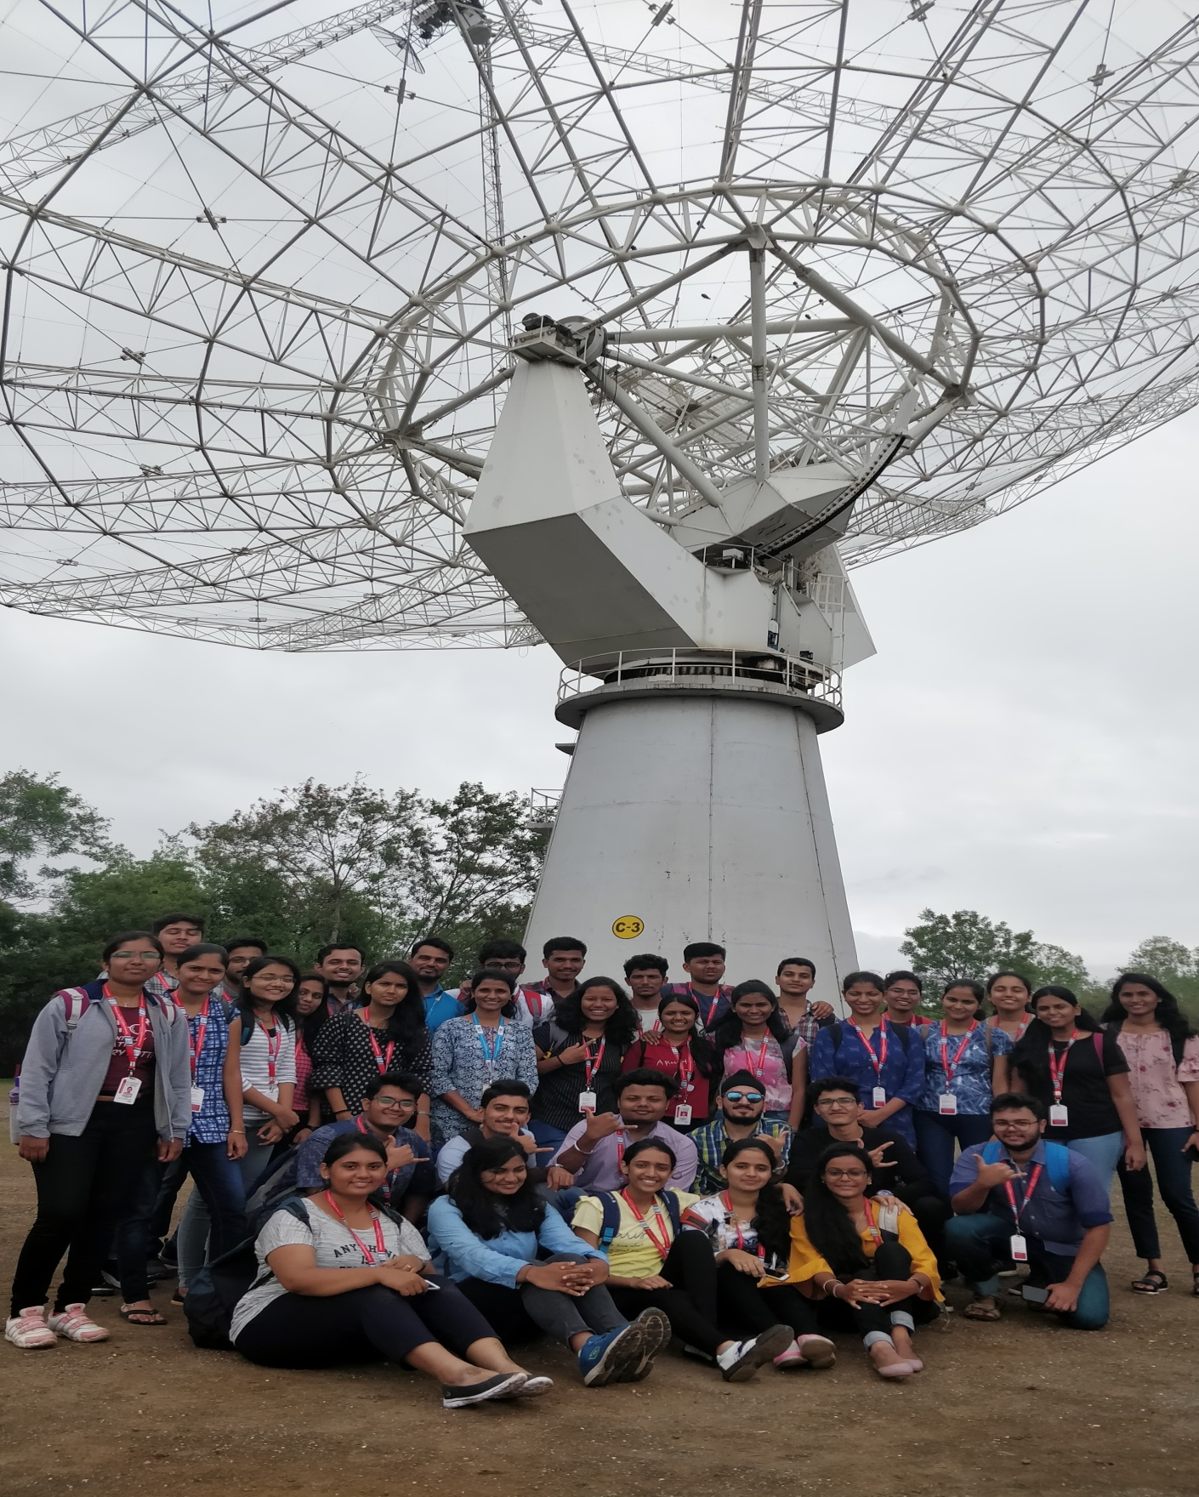

About GMRT.:
GMRT is an indigenous project. The construction of 30 large dishes at a relatively small cost has been possible due to an important technological breakthrough achieved by Indian Scientists and Engineers in the design of light-weight, low-cost dishes. The design is based on what is being called the `SMART' concept - for Stretch Mesh Attached to Rope Trusses. The dish has been made light-weight and of low solidity by replacing the conventional back-up structure by a series of rope trusses (made of thin stainless steel wire ropes) stretched between 16 parabolic frames made of tubular steel. The wire ropes are tensioned suitably to make a mosaic of plane facets approximating a parabolic surface. A light-weight thin wire mesh (made of 0.55 mm diameter stainless steel wire) with a grid size varying from 10 X 10 mm in the central part of the dish to 20 X 20 mm in the outer parts, stretched over the rope truss facets forms the reflecting surface of the dish.

