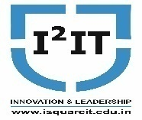
Hope Foundation’s
International Institute of Information Technology,
Hinjawadi, Pune – 411057

Activity Report
(Guest lecture on Business Analytics and Business Intelligence)

Academic Year: 2020-21 (SemI)
Name of Event: Guest Lecture
Topic: Business Analytics and Business Intelligence

Date & Time of Conduction: 14th Sept 2020 (10 am to 12.30 noon)
Targeted Audience: FinalYear Students
Venue: Online session
Coordinator: Prof.BhavanaKanawade
Number of Participants: 48
Activity Description: Mr. Vijay Amritkar from Capgemini conducted the session on the specified topic. Power Bi Desktop, visualisations, relationship management, power BI data sources, DAX, Power BI services, Dashboard vs. reports, and automation were the subjects discussed in the session. Students were asked to submit an assignment on the basis of the topics learned after completing the session. This session was conducted to make students aware about BI tools used in industry. Students learned how to use BI tools and how to do data analysis. This session was related to subject Business Analytics and Intelligence(BAI)

Event Photos:
Explanation of what is business Intelligence

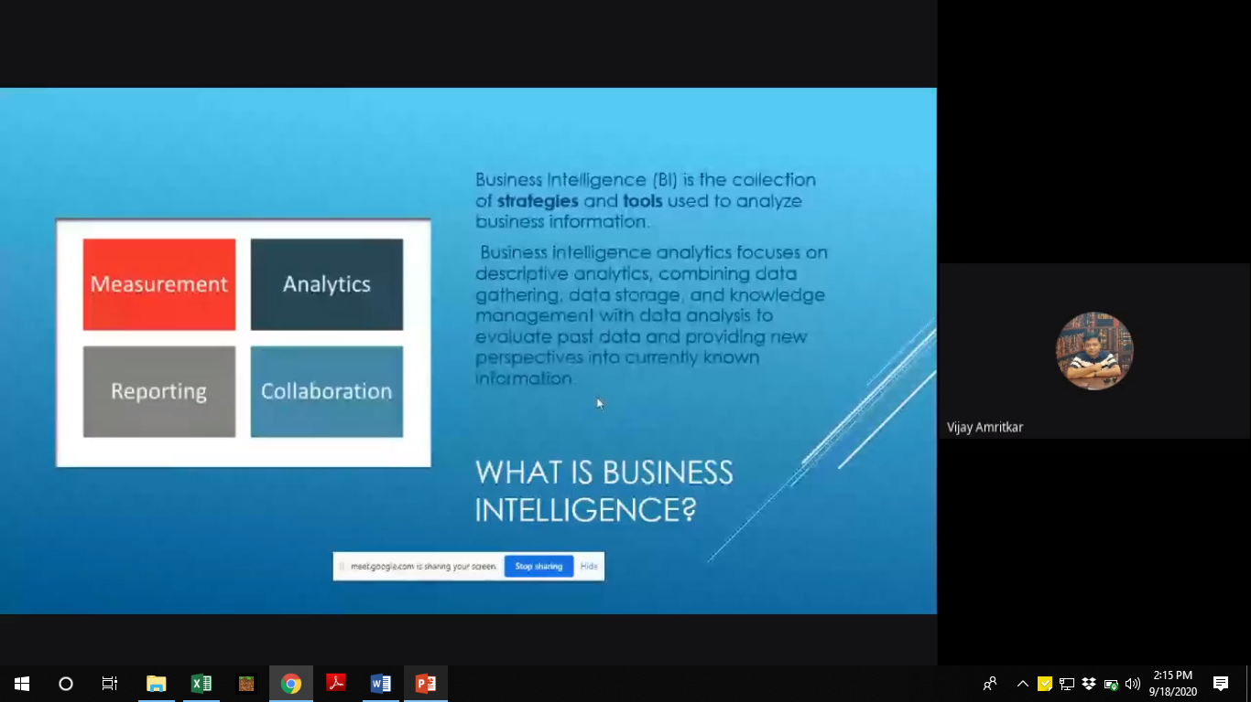

Demonstration of how to activate Microsoft cognitive services

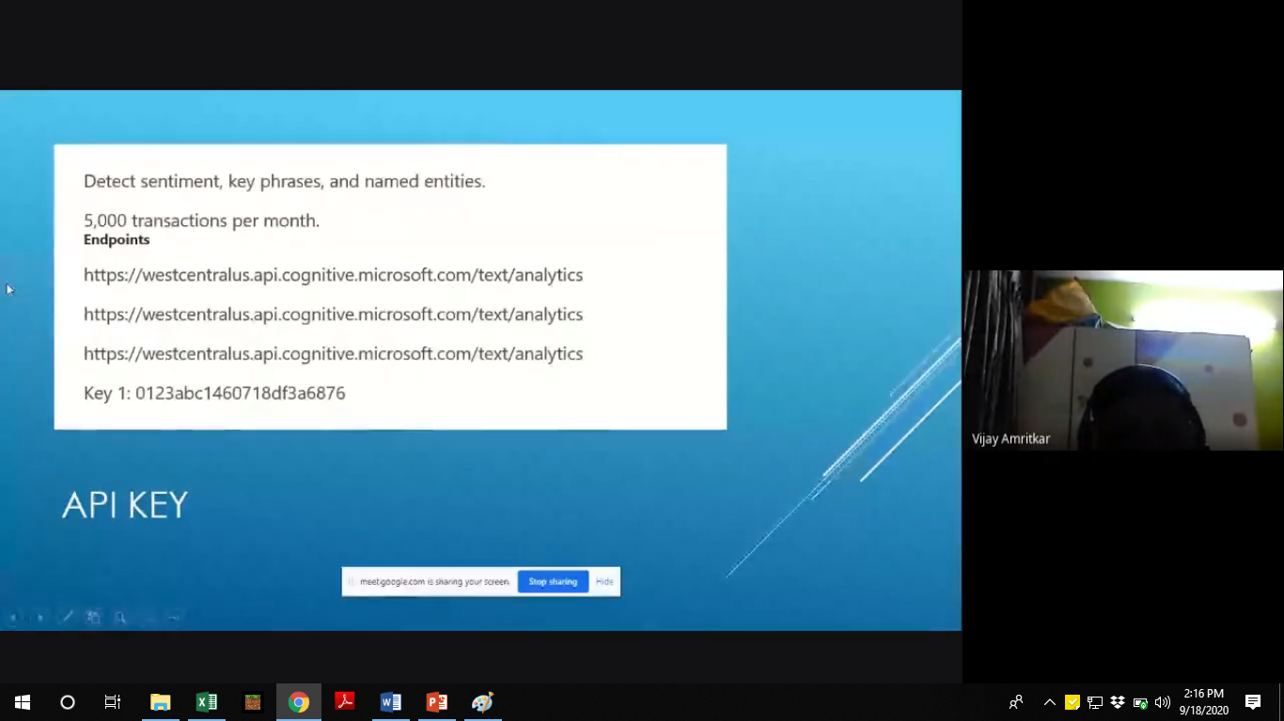

Demonstration of Azure cognitive services

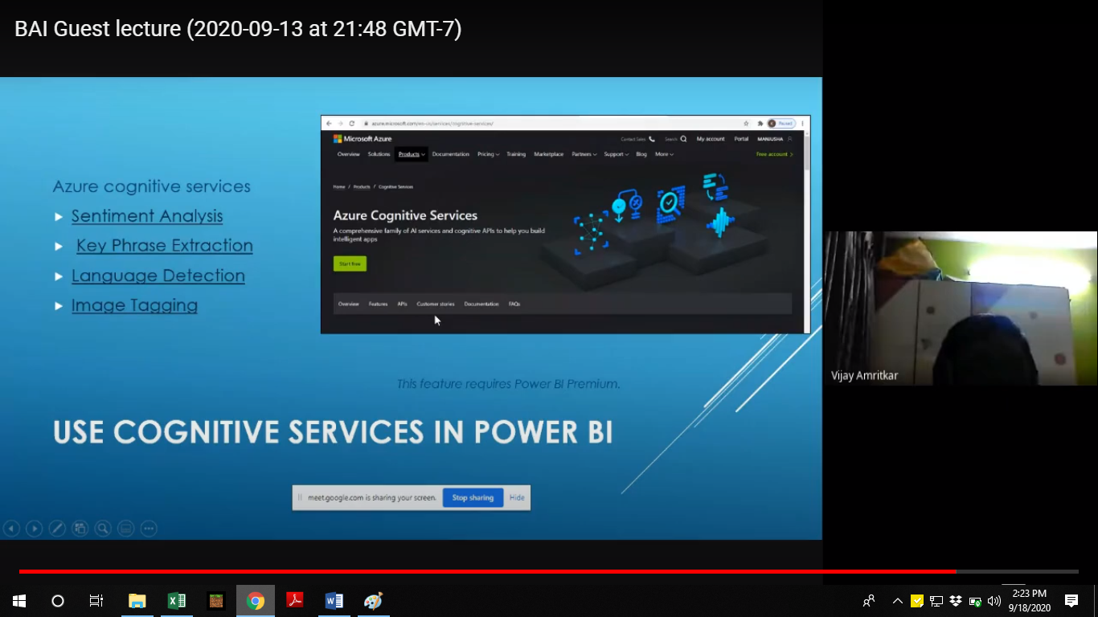

Overview of Power BI tools

