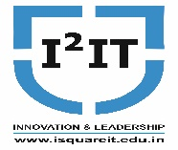
Hope Foundation’s
International Institute of Information Technology,
Hinjawadi, Pune – 411057

Activity Report
(Guest lecture onOperating System)

Academic Year: 2020-21 (SemI)
Name of Event: Guest Lecture
Topic: Linux Operating System Internals

Date & Time of Conduction: 11th November 2020 (12 pm to 2.30 pm)
Targeted Audience: ThirdYear Students
Venue: Online session
Coordinator: Prof.BhavanaKanawade
Number of Participants: 46
Activity Description in Nutshell: Mr. AmolShende conducted the session on the specified topic. The speaker covered topics like Linux booting process, repair system boot issues, user and group administration, Linux file system.
Event Photos:

Explanation of Linux Booting Process

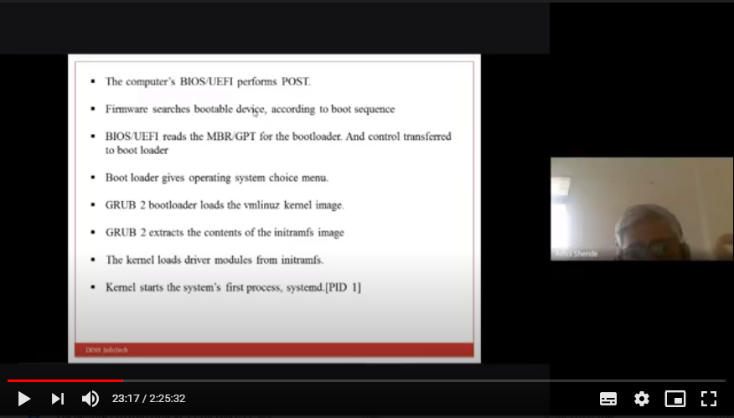

Demonstration on how to repair system boot issues

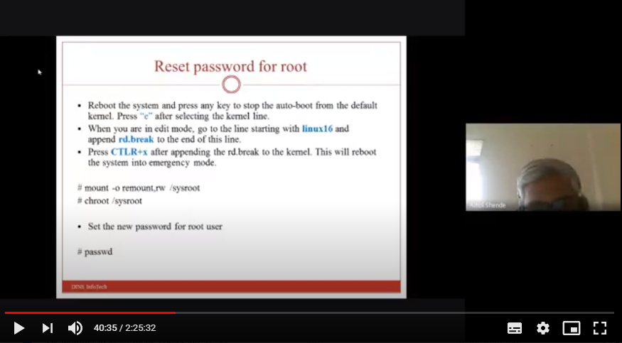

Demonstration of User and group administration

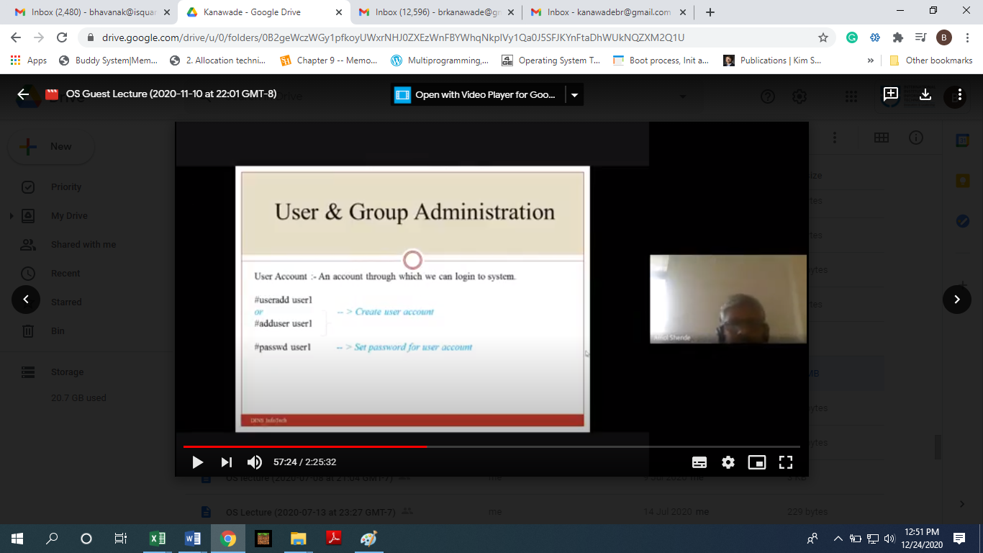

Explanation of Linux file system

