Hope Foundation’s
International Institute of Information Technology (I²IT)
Hinjawadi, Pune- 411057

Department of Information Technology

Activity Report

Guest Lecture

Academic Year: 2020-21
Semester: I
Name of Event: Guest Lecture

Date of Conduction: 15th September 2020
Time: 10:00 AM to 12:00 PM
Targeted Audience: SE IT
Number of Participants: 65
Venue: Online
Topic: “Foundations of Data Structures”
Resource Person: Dr Abhijat Vichare
Coordinator: Prof. Manjusha Amritkar
Objectives:

To introduce the new concepts of data structures this will be helpful in the future

Outcomes:
Students will be able to apply the fundamentals of data structures.
Activity Description:
Data structures are one of the most important parts of the computer world, still each time the same thing is learnt and taught by many. We often forget to look at these structures differently. This time, in an Online Guest Lecture, Dr. Abhijat Vichare, an ACM India eminent speaker, taught the 2nd year IT students a different way of looking at data and data structures.
Started with the most basic explanation about what data is, why structuring it is important, moving to the Abstraction of this data, going deep till the bits and bytes, explaining the concept of the standardization, and the basics in simple terms.
Aggregation, a bunch of data types brought together to create a new type; Containers, strategies or methods to contain this data, like Lists, Trees, Graphs etc and Constraints ,conditions imposed on using the types, aggregations or containers, like FIFO(queue) ,LIFO(stack) ,etc. , are just other ways for explaining Data Structures into more simpler terms. This being just the thing needed to get the students on their feet, the best was saved for the last.
Lists, the linear container, were the focus of this lecture by Mr. Abhijat. More than theoretical, a mathematical approach was being taken to make the students understand the recursive structure of the list container, rather than the sequential structure that we all habitually make use of. The idea to use the recursive functions, for calculations, like, sum, product, etc. was just using smaller functions where we could get the desired results. Making one BIG accumulator, in his words, which combines all these functions, and just passing the required parameters, would be an interesting approach to this recursive list structure. This explanation, being an interesting and also a difficult to understand way of recursion, left the students wondering and thinking about it. Opening some different approaches to the Data Structures rather than frequently used forms definitely made some impact on the students and the teachers as well.
Activity Photos:
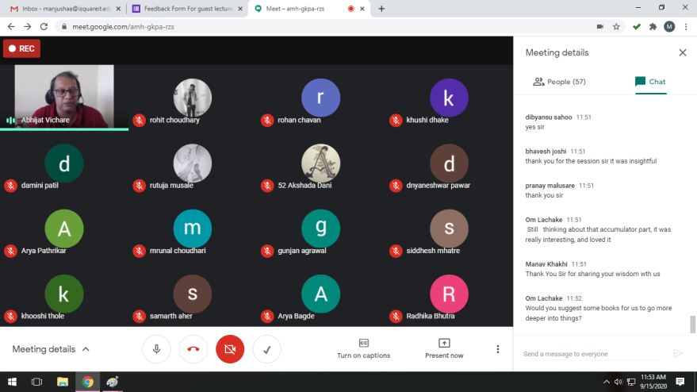
Dr. Abhijat Vichare with students
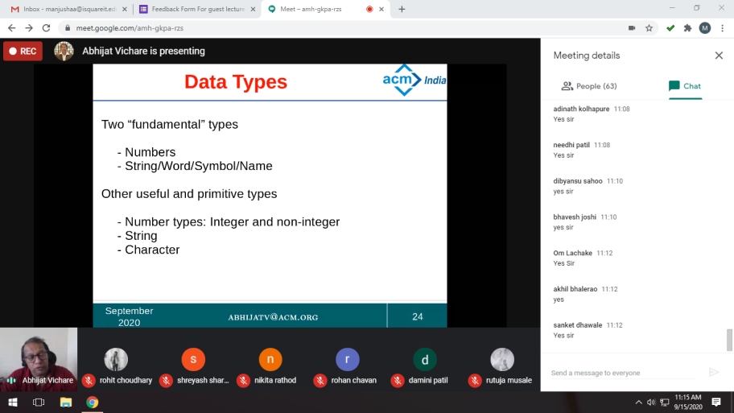
Dr Abhijat Explaining fundamentals
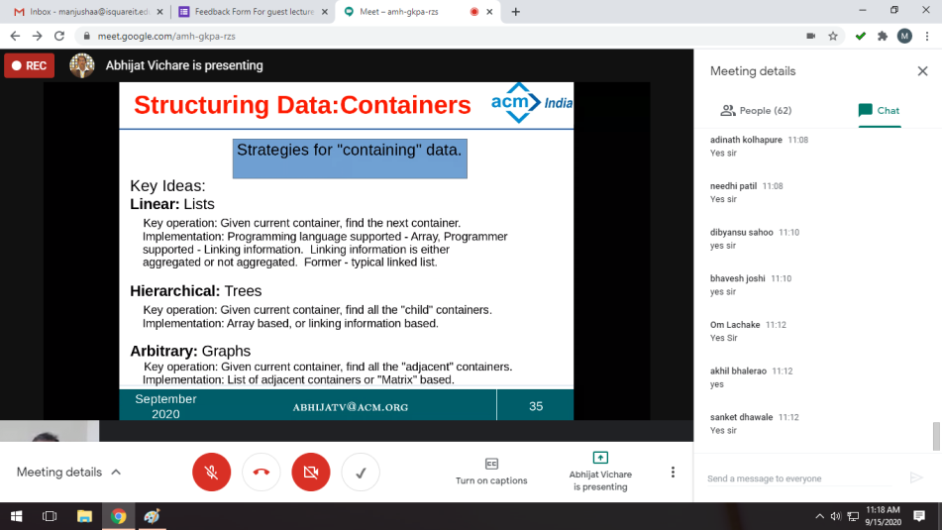
Dr Abhijat explaining containers

