REPORT OF VISIT TO LAVALE VILLAGE ON 14/9/19
Introduction:-lavale is a village in mulshi taluka on the outskirt of Pune. Lavale Village is known for the cultivation of various crops like onion, rice, jamar, potatoes, and other vegetables. Guava is the most cultivated fruit. The atmosphere of the village and its surroundings is mostly cooler than that of the cityThe Mula River passes through this region, and flowing through Wakad and Baner areas as it makes its way to Pune.
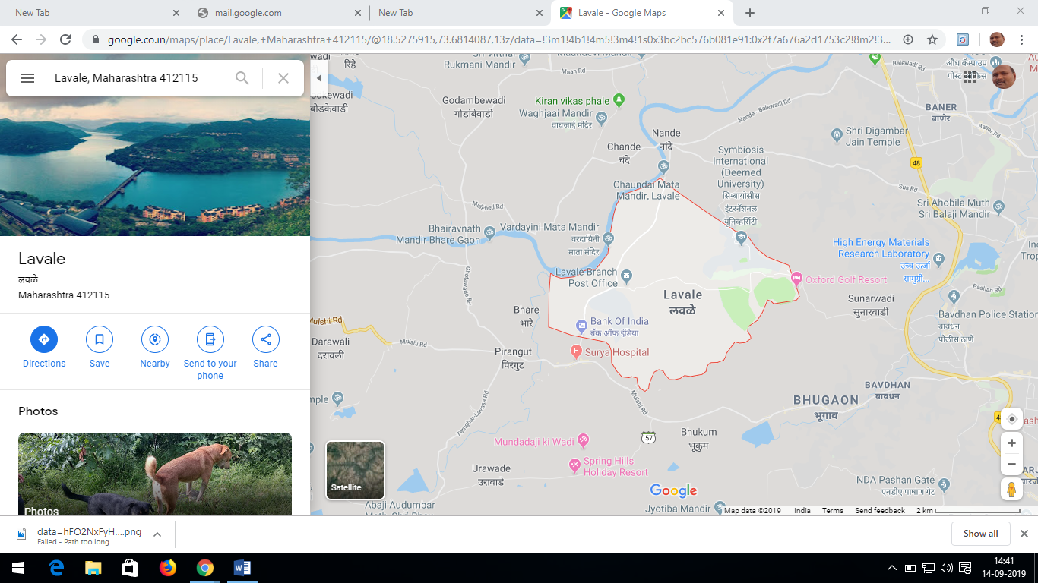
LOCATION OF VILLAGE

According to Census 2011 information the location code or village code of Lavale village is 556128. Lavale village is located in Mulshi Tehsil of Pune district in Maharashtra, India. It is situated 8km away from sub-district headquarter Paud and 15km away from district headquarter Pune. As per 2009 stats, Lavale village is also a gram panchayat.
The total geographical area of village is 1960 hectares. Lavale has a total population of 6,732 peoples. There are about 1,537 houses in Lavale village. Pune is nearest town to Lavale which is approximately 15km away.

Population of Lavale
Population of Lavale Village
Male = 3621
Female =3111
Total= 6732
The our Institute has idientified neighbor village as a Lavale as a Jal Shakti Village and formed a Gram Jal Shakti Team for development of water conservation system in the village.
The institute has prepared the Gram Jal Shakti Team as follows
Sr No | Name of the Member | Designation
1 | Swati Kadam | Sarpanch
2 | Vaishali Satav | Ex Sarpanch
3 | Vaibhav Kudale | Member Gram Sabha
4 | Machindra Kashilkar | Member Gram Sabha
5 | Sanjay Satav | Member Gram Sabha
6 | Mahesh S Waghmare | Faculty
7 | Dr Sandeep Varpe | Faculty
8 | Dr Varsha Degaonkar | Faculty
9 | Siddhant Dhokrat | Student TE COMP
10 | Mayur Surkar | Student BE ETC
12 | Swapnil Chore | Student TE COMP
13 | Anita Raut | Student TE COMP
14 | Pratiksha Ghule | Student SE ETC
15 | Mahesh Patil | Students SE COMP

Existing Water Management in Village: - The team has made a survey in the village and following observation has been made.
- There is a one Mula River in the village and intake well in constructed near the river. The water is lifted with the motor and transported to elevated surface reservoir (ESR)with a capacity of 3 lakh liter . Then this water is transported to the filter plant for treatment for purification purpose.The drinking water is provides at 4 to 5 location in the village where villagers can take water for drinking purpose. The water which is required for other domestic use is supplied with the pipe line and tap directly at home.
- Now there is no any drainage system for village to pass storm water.
- Now there is no any sewage treatment plant because it is not affordable to village.
- In summer season there is a water scarcity but it is managed by transporting water from one well to another well.
Suggestion to improve water conservation in the village
- Rain water harvesting to every house and structure in the village to store rain water under the ground and percolate and improve the water table.
- Construction of check dam/ KT weir for selected site for water conservation.
- Contour trenches/ nala bunding on the hill to percolate water in the ground
- Farm pond as a water bank in the village
- Water literacy program to be conducted.

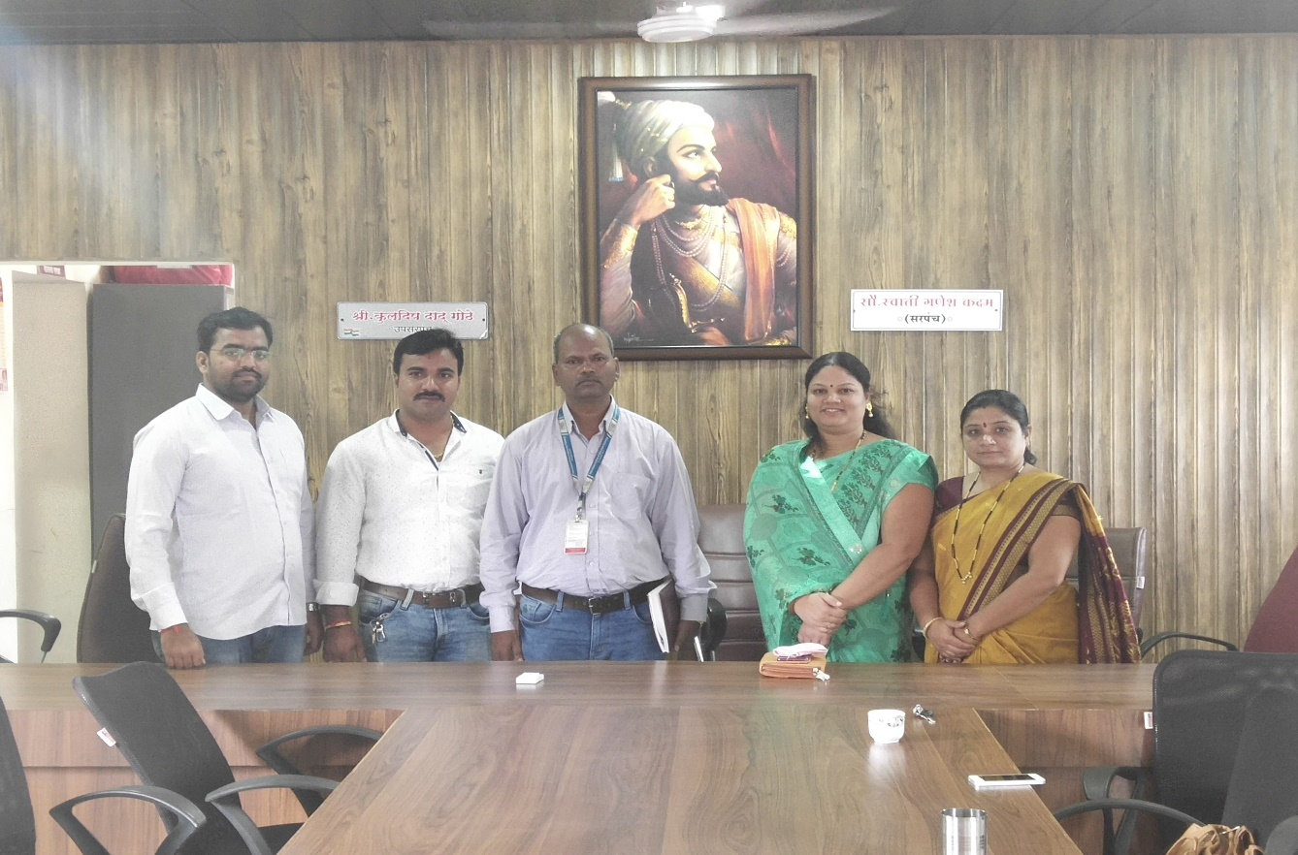
Meeting with sarpanch office
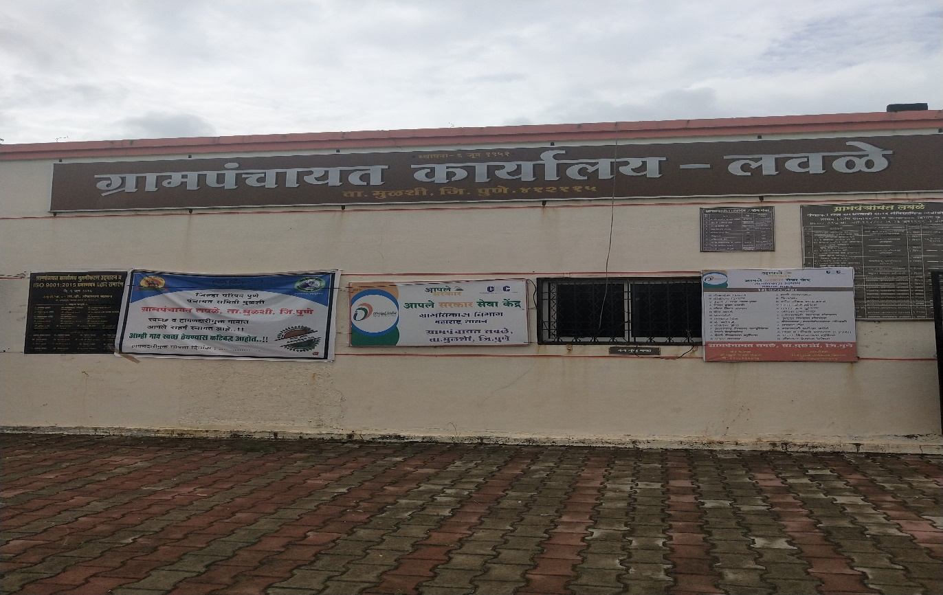
GRAMPANCHAYAT OFFICE AT LAVALE

The rain water harvesting system is installed in the campus. The campus having sloping topography , so using this physical featutes we have taken a well near the research center building so that whatever water is getting in rainy season in this way water get collected in the underground tank and also opersolation takes place and water table level is also increasing in that area.The rain water harvesting methos is the need of the hour and all should adopt this method for conservation of water.

