A Piece of Social Work
“NSS Camp at Jambawade”

(30th December 2018 to 5th January 2019)

Organized By



P-14, Rajiv Gandhi Info Tech Park, Phase – 1,
Hinjawadi, Pune – 411057, India

National Service Scheme (NSS) Unit

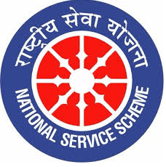

CLEANLINESS CAMPAIGN
The NSS units of Hope foundation’s International Institute of Information Technology, Hinjawadi Pune and Rajeshri Shahu College of Engineering had organized a one week camp in the Jambavade Village situated in Maval Taluka of Pune. This camp was organized from 30th December 2018 to 5th January 2019. The major activity of this camp was to run Cleanliness Campaign along with other social activities. | 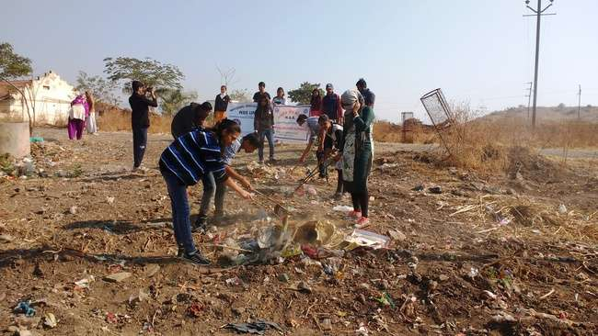
 | 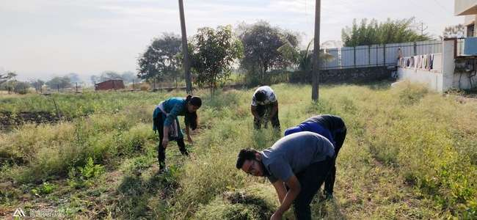

Construction of Earthen Dams

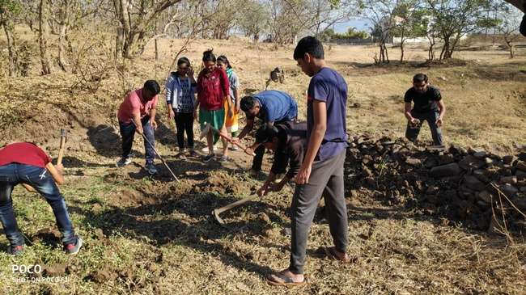 | The NSS units of Hope foundation’s International Institute of Information Technology, Hinjawadi Pune and Rajeshri Shahu College of Engineering had organized a one week camp in the Jambavade Village situated in Maval Taluka of Pune. This camp was organized from 30th December 2018 to 5th January 2019. The camp had decided that construction of dams which was a part of social work of the camp would be held on third and fourth day of camp.
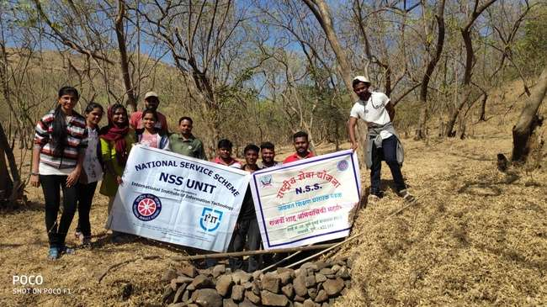

NSS Rally

The NSS unit of Hope foundation’s International Institute of Information Technology, Hinjawadi Pune and Rajeshri Shahu College of Engineering had organized a one week camp in the Jambawade Village situated in Maval Taluka of Pune. This camp was organized from 30th December 2018 to 5th January 2019. During the camp the team decided to organize a rally for awareness about de-addiction of drugs, girl education and cleanliness. This rally was organized on 2nd January 2019. | 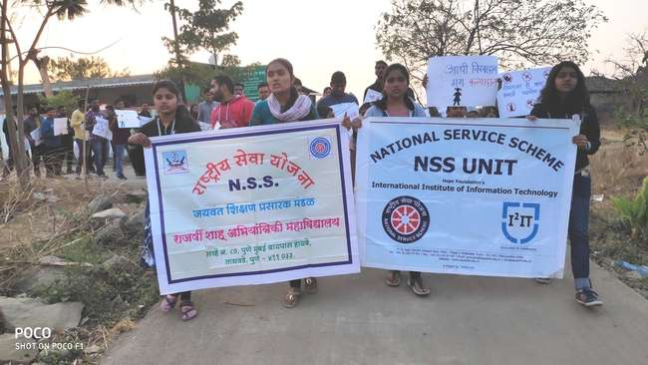
 | 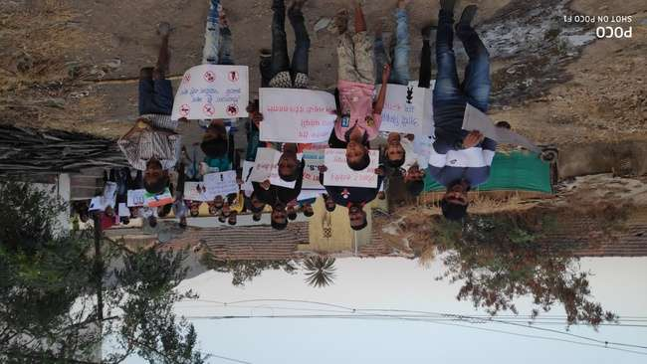

Guest Lectures
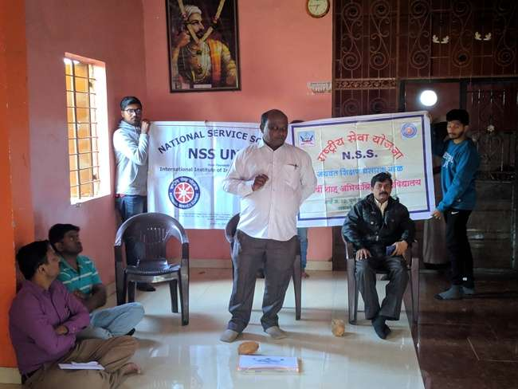 | The NSS units of Hope foundation’s International Institute of Information Technology, Hinjawadi Pune and Rajeshri Shahu College of Engineering had organized a one week camp in the Jambawade Village situated in Maval Taluka of Pune. This camp was organized from 30th December 2018 to 5th January 2019. During different guest visited to camp, some of them taken lecture on different issues in society. On 31/12/2018 Prof. Dhananjay Bhise talk about Samarth and Saksham Bharat, on 02/01/2019 Mr. Nilesh Chavan Talk on Power of Youth and 04/01/2019 delivered lecture on Organic farm an Experiment
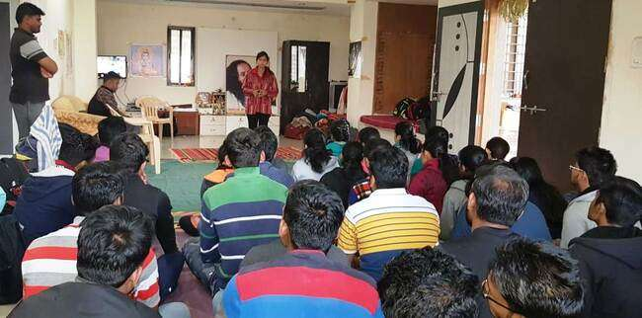

Visit to Historical Place
“ Bhandara Dongar ”

All team members decided to visit the a Historical Place Bhandara Dongar on sixth day of camp 04th Jan 2019. All Five Teams visited Bhandara hill which is a great devoted place of villagers. On that day all Five Teams after having their breakfast arrived at 9:30 a.m. towards Bhandara Hill. All Teams together started climbing the hill. Everyone reached the hill by 11:00 p.m. There was a temple of Sant Tukaram Maharaj. We went to The Temple and worshiped God. After that we took information about the temple from the Villagers. Then the Villagers served us Food. After lunch, we served food to the Villagers. Then we cleaned the Surrounding area of the temple.  It was a great Experience for all The Students. | 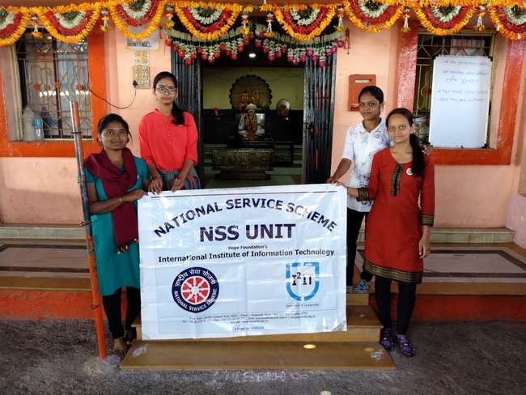
 | 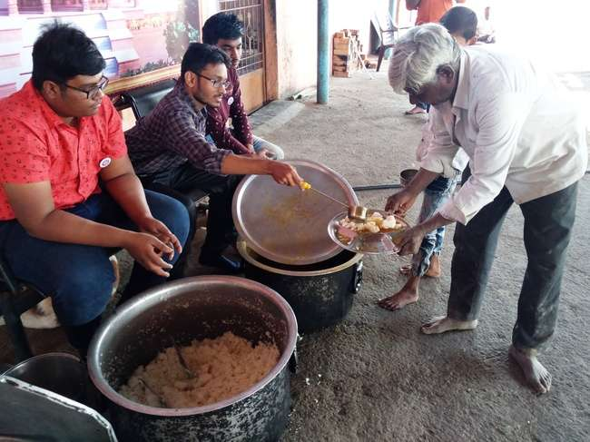

Study Visit to
“JADHAVWADI DAM”
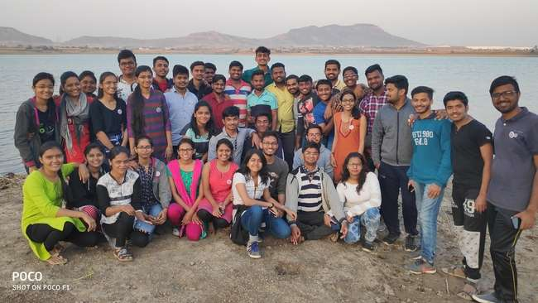 | During the camp it was decided to visit the Jadhavwadi Dam on the fifth day to study the construction of the dam and the backwater region.  The team visited the dam on 3rd January in the evening at 4:30 pm. This dam is an earthen dam. It’s total length is 1215 meter, and it’s foundation height is 36 meters. The purpose of building this dam was to bring the surrounding land under water and irrigation. We enjoyed the sunset at the dam.
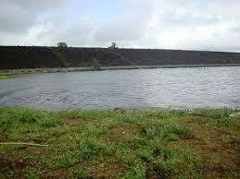

A Study Visit

“Polyhouse : Plant Biodiversity”

The NSS unit had organized a visit to polyhouse on 3rd January, 2019 at 5:30 pm. Mr. Somnath Chorghe, owner of the polyhouse explains students and faculties the construction and working of polyhouse and the flower business. Mr. Somnath told us the overall working of his business. Also he explained the scientific process of farming flowers. Along with this information he shares the economics of the business. | 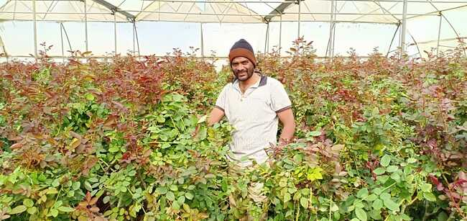
 | 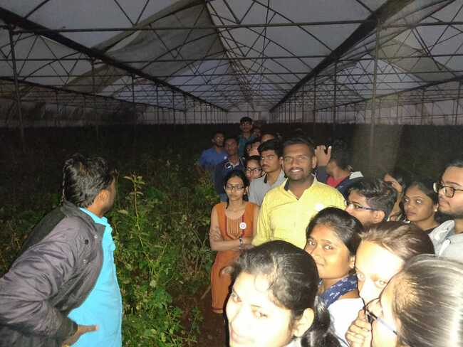

Dr. Sandeep Varpe |  | Dr. Vaishali Patil
NSS Programme Officer |  | Principal

