“Voter Registration/Correction Drive”

(26th August 2019- 24th September 2019)

Organized By

P-14, Rajiv Gandhi Info Tech Park, Phase – 1,
Hinjawadi, Pune – 411057, India

National Service Scheme (NSS) Unit

National Service Scheme (NSS) Unit

Academic Year 2019-20

REPORT
The NSS units of Hope Foundation’s International Institute of Information Technology, Hinjawadi Pune had organized a one month Voter Registration camp at I²IT College situated in Mulshi Taluka of Pune District. This Voter Registration Drive was organized from 26th August 2019 to 24th September 2019. During the drive around 103 people were helped for various Voter ID facilities like New Voter Registration, Updating of Voter Id, etc.
During the drive, NSS Volunteers first did the survey of all college students, teaching and non-teaching staff who don’t have Voter ID’s. Communicating by E-mail and Information Broachers, List of all essential required documents needed for registration and updating of Voter ID was circulated. There list was made and accordingly their registration was done by the volunteers. The volunteers had spread awareness about the process for registering for Voter id through online portal. In this way the Voter registration/correction drive was been carried out successfully by NSS unit in an Institute.
National Service Scheme (NSS) Unit

Photographs of the Event

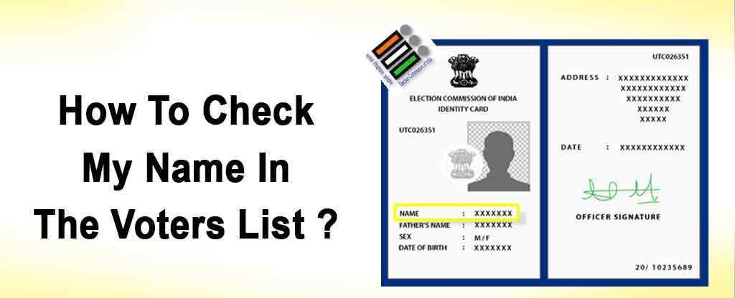

Steps to Apply Online for Voter Registration.
National Service Scheme (NSS) Unit

Photographs of the Event

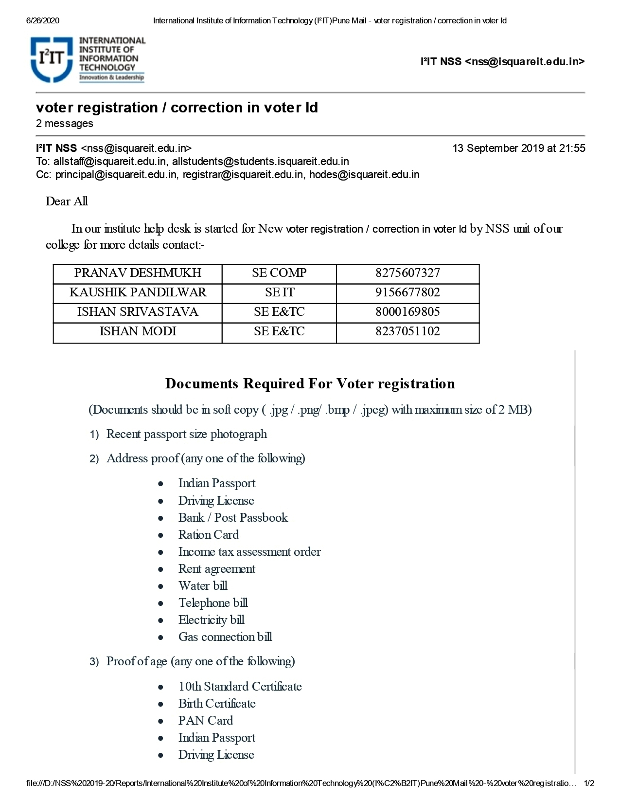

National Service Scheme (NSS) Unit

Photographs of the Event

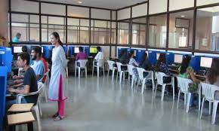

Students filling Details on online portal.

National Service Scheme (NSS) Unit

Photographs of the Event

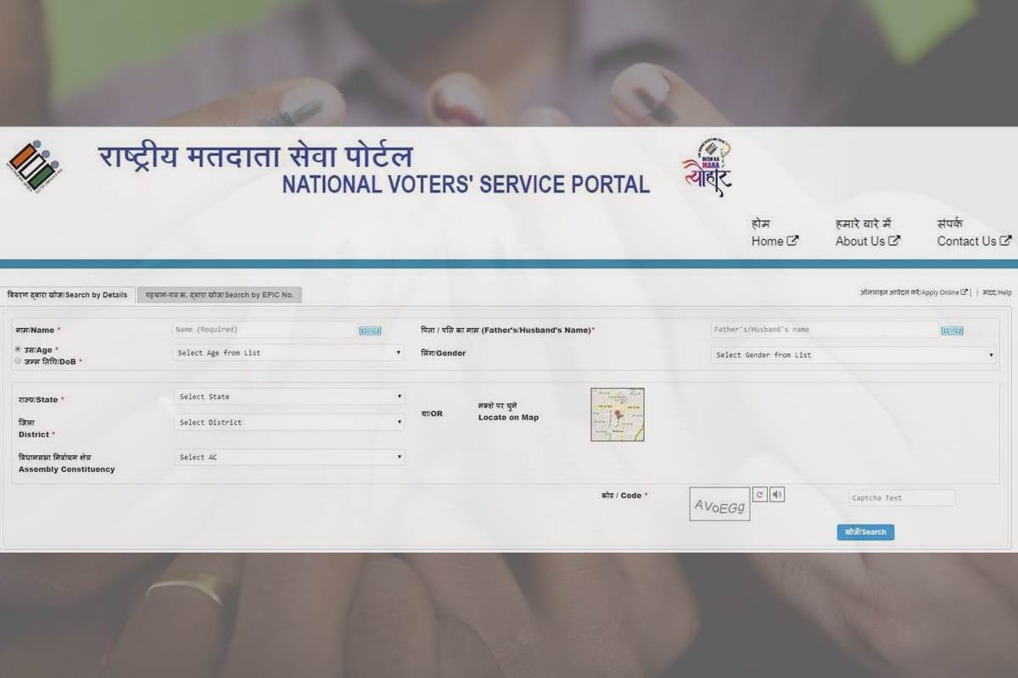

Online Registration Portal Link (https://www.nvsp.in/)

- Names & Voter Reference Numbers of some of the Registered Students who registered/corrected their Voter ID are as follows:-

1.Wasim Patwari | (FE COMP) | OED205622062
2.Komal Deore | (SE IT) | OKL733170394
3.Kamal Kant | (TE E&TC) | OGD466736632
4.Sanskriti Oza | (BE) | OGD647758273
5.Omkar Bhor | (SE IT) | OHD637366482
6.Tejas Sole | (SE COMP) | OHS636646747
7.Wilayat Ali | (SE COMP) | OGK647737477
8.Yash Jane | (SE IT) | ORR506032095

